|  |
| --- |
| User Manual  Unit HR & HR Manager(HRM & DM) |
| REFERENCE: GW/ERP/USER MANUAL |
|  |
| **Genweb2 Ltd.** |
| **18-Aug-20** |



|  |
| --- |
|  |

Contents

A. Document Information 6

B. Document History 7

C. Introduction: 8

1. Leave Request 8

1.1 Create Leave Request 8

1.2 Create Leave Allocation Request 10

2. Leave Request Approval by Unit HR 11

2.1 Leave Summary 11

2.2 Leave Request approval by unit HR 12

3. Leave Allocation Request Approval by Unit HR 14

3.1 Leave Allocation Request Approval by Unit HR 14

4. Short Leave Request 14

4.1 Create Short Leave Request 14

5. Short Leave Request Approval by Unit HR 16

5.1 Short Leave Approval Request by Unit HR 16

6. Attendance 17

6.1 Create Manual Attendance 18

7. Manual Attendance Request Approval by Unit HR 19

7.1 Pending Manual Attendance 19

7.2 Approval Manual Attendance Request by Unit HR 20

7.3 Create Alter Rostering 20

7.4 Approval Alter rostering Request by HR unit 22

8. OT Requisition 23

8.1 Create a OT Request 23

9. OT Request Approval by Unit HR 24

9.1 OT Approval Request by Unit HR 24

10. Configuration by HR Manager 26

10.1 Create Leave type configure by HR Manager 26

10.2 Create Holidays configure by HR Manager 27

10.3 Create Holiday Calendar configure by HR Manager 29

10.4 Create Leave years configure by HR Manager 30

10.5 Create Attendance login grace time configure by HR Manager 31

10.6 Create Loan types configure by HR Manager 32

10.7 Create Loan policies configure by HR Manager 33

10.8 Create Loan proofs configure by HR Manager 34

11. Leave request by HR manager 36

11.1 Create Leave Request 36

11.2 Create Leave Allocation Request by HR manager 39

12. Leave Request Approval by HR manager 40

12.1 Leave Summary 40

12.2 Leave Request approval by HR manager 40

13. Leave Allocation Request Approval by HR manager 42

13.1 Leave Allocation Request Approval by HR manager 42

14. Short Leave Request 42

14.1 Create Short Leave Request 43

15. Short Leave Request Approval by HR manager 44

15.1 Short Leave Approval Request by HR manager 44

16. Attendance for HR manager 46

16.1 Create Manual attendances batches for HR manager 46

17. Manual attendances batches request approval by HR manager 47

17.1 Pending Approval batches 47

17.2 Approval Manual Attendances batches Request by HR manager 48

17.3 Create Alter Rostering 49

17.4 Approval Alter rostering Request by HR manager 50

18. OT Requisition 51

18.1 Create a OT Request 52

19. OT Request Approval by HR manager 53

19.1 OT Approval Request by HR manager 53

20. Employee 55

20.1 Create Employee 55

21. Contracts 56

21.1 Create contracts 56

22. Employee IOU 57

22.1 Create employee IOU 57

23. Departments 58

23.1 Create departments 58

24. Loan Request 59

24.1 Create Loan Request 59

25. Loan request approval by HR Manager 61

25.1 Loan request Approve by HR manager 61

26. Loans to disburse 62

26.1 Create a Loan disburse 62

27. Mobile bills 64

27.1 Create a mobile bills 64

28. Mobile bills Approval by HR manager 65

28.1Mobile bills Approval by HR manager 65

29. Mobile bill limits 66

29.1 Create a mobile bill limits 66

30. Mobile bill limits Approval by HR manager 68

30.1Mobile bill limits Approval by HR manager 68

31. Meal bills 69

31.1 Create a meal bills 69

32. Meal bill Approval by HR manager 70

32.1Meal bill Approval by HR manager 70

33. Arrear 71

33.1 Create a arrear 71

34. Arrear Approval by HR manager 72

34.1 Arrear Approval by HR manager 73

35. Other Allowance 74

35.1 Create an Other allowance 74

36. Other allowance approval by HR manager 75

36.1 Other allowance approval by HR manager 75

37. Reports 77

37.1 Yearly salary by head reports view by HR manager 77

37.2 Yearly salary by employee reports view by HR manager 78

37.3 Attendance reports view by HR manager 78

37.4 Daily attendance summary reports view by HR manager 79

37.5 Error attendance summary reports view by HR manager 80

37.6 Attendance analysis reports view by HR manager 81

37.7 Leaves analysis reports view by HR manager 81

37.8 Leaves summary reports view by HR manager 82

37.9 Employee Leaves summary reports view by HR manager 83

1. Document Information

|  |  |
| --- | --- |
| Document Name | User manual(Unit HR & HR manager) |
| Document Author | Rashedul Alam |
| Document Version | 1.2 |
| Release Date |  |

|  |  |
| --- | --- |
| Review by | Matiar Rahman |
| Review Date | Apr 2, 2018 |
| Approved By | Matiar Rahman |
| Approval Date | Apr 2, 2018 |
| Review by | Md. Mahfuzur Rahman |
| Review Date | 19-Aug-2020 |
| Approved By | Md. Mahfuzur Rahman |
| Approval Date | 19-Aug-2020 |

1. Document History

|  |  |  |  |  |  |
| --- | --- | --- | --- | --- | --- |
| A=Added, M=Modified, D=Delete | | | | | |
| **Version No** | **Date** | **Section No** | **A/M/D** | **Description of Change** | **Author** |
| 1.0 | 25-Jan-2017 |  | A | Initial | Rashedul Alam |
| 1.1 | 2-april -2018 |  | M | Added 8 process. Employee, Employee loan, Mobile bill process, Arrear, Other allowance, Meal bills, Employee configuration, Reports. | Rashedul Alam |
| 1.2 | 18-Aug-2020 |  | A/M/D | Remove all images & Added all new images, Modify some text. |  |

# Introduction:

This User manual is to clearly identify the customer requirements and provide a detailed document. This user manual will contain HR manager related all information. HR manager will read this document and get a clear view the HR module. It will also help the review team to validate whether the customer requirements have been fulfilled or not.

# 1. Leave Request

Unit HR is capable to his/her own leave request and on behalf of employee. He/she will approve leave request under his all employee against.

## 1.1 Create Leave Request

For create a leave request we have to go leave menu then create a leave request.

Using the menu **Leave ‣ My Leaves ‣ Leave Request** click **Calendar** button.

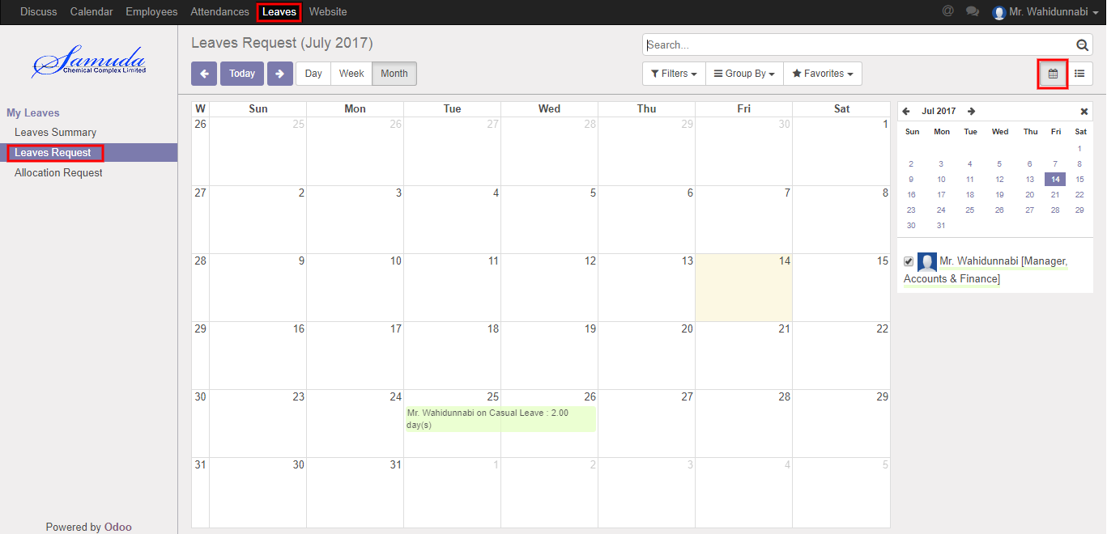

**Fig:** Leave Calendar View

Also we can see using the menu **Leave ‣ My Leaves ‣ Leave Request** click **List** button.

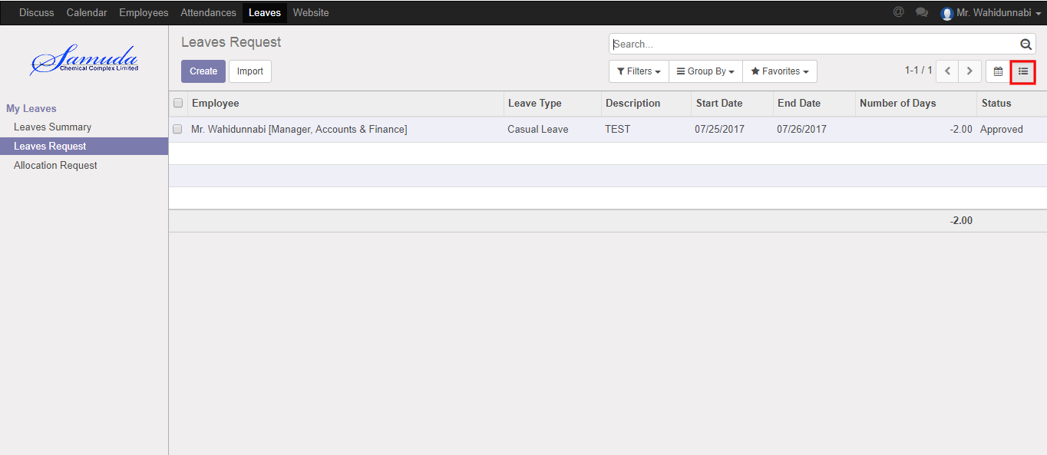

Figure**:** Leave List View

To create new Leave Request, Using the menu **Leave ‣ My Leaves ‣ Leave Request** click **Create**.

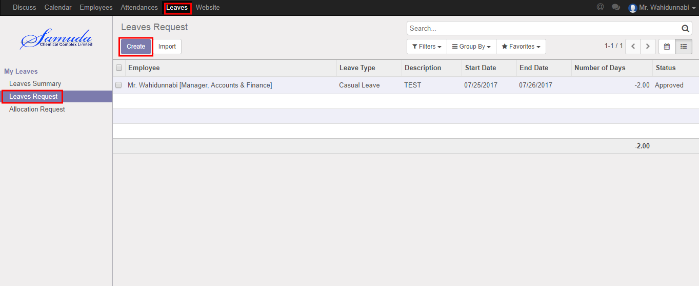

You can set the following information:-

**Description:** Enter some description.

**Leave Type:** Select a leave type.

**Duration:** Select duration of leave.

After entering the Leave Request information click **save**.

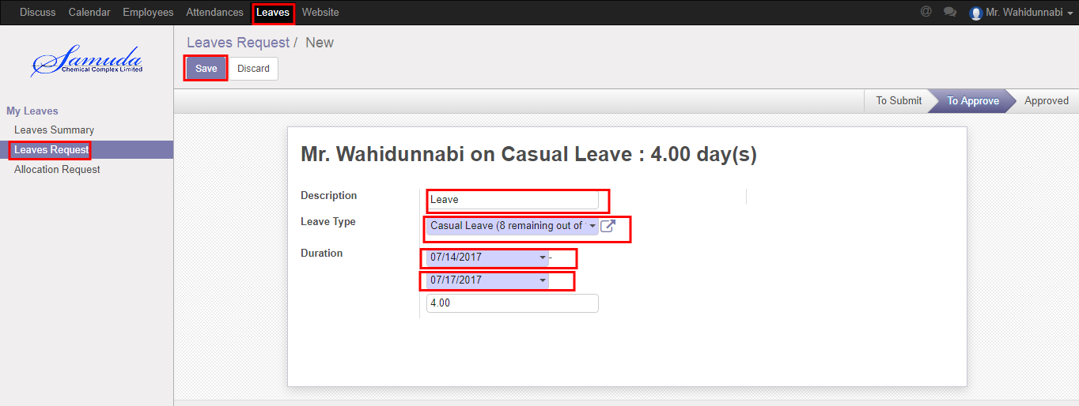

Figure: Create a Leave Request

After apply the leave request respective “Unit HR” will get the notification. Unit HR approve the leave request. He can update number of leave day(s) before approval. . He Can Approve or Refuse the leave request. After that requested leave will finally approve.

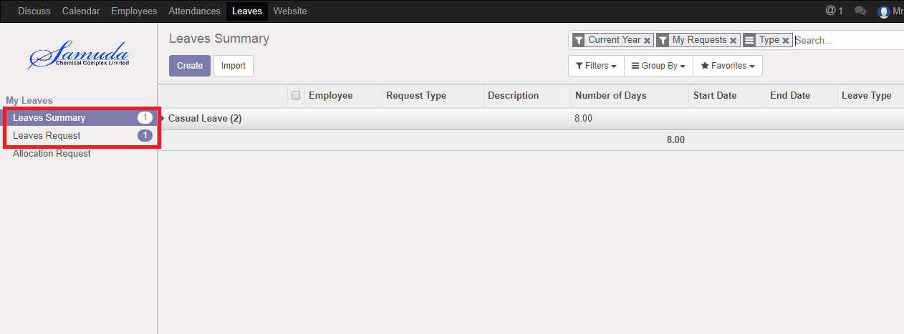

Figure: Leave Request Notification

## 1.2 Create Leave Allocation Request

Unit HR is capable to his/her own leave allocation request and he/she will approve leave allocation request under his all employee against.

For create a leave allocation request we have to go leave menu then create an allocation request.

Using the menu **Leave ‣ My Leaves ‣ Allocation Request** click **Create**.

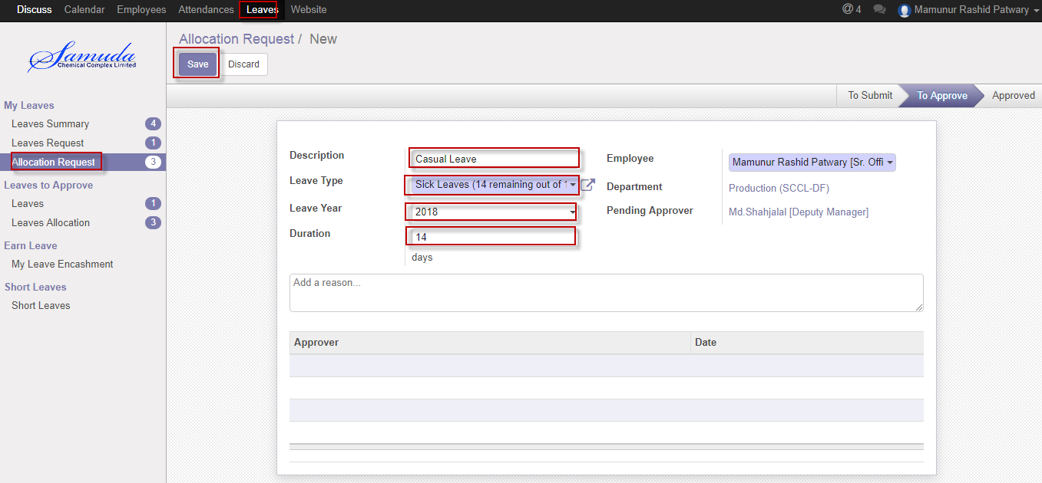Figure: A Leave Allocation Request

After apply the leave allocation request respective “Unit HR” will get the notification. He can approve or Refuse the leave allocation request. He can update number of day(s) before approval. Manager Can Approve or Refuse the leave allocation request. After that requested leave allocation will finally approve.

# 2. Leave Request Approval by Unit HR

Unit HR will approve leave if He/she exists in Approval chain.

## 2.1 Leave Summary

Only approver hierarchy user can see all of employee leave Summary/Leave allocation/Leave request, if He/she exists in set custom chain level. Which will set to employee profile form?

Using the menu **Leave ‣ My Leaves ‣ Leave Summary**.

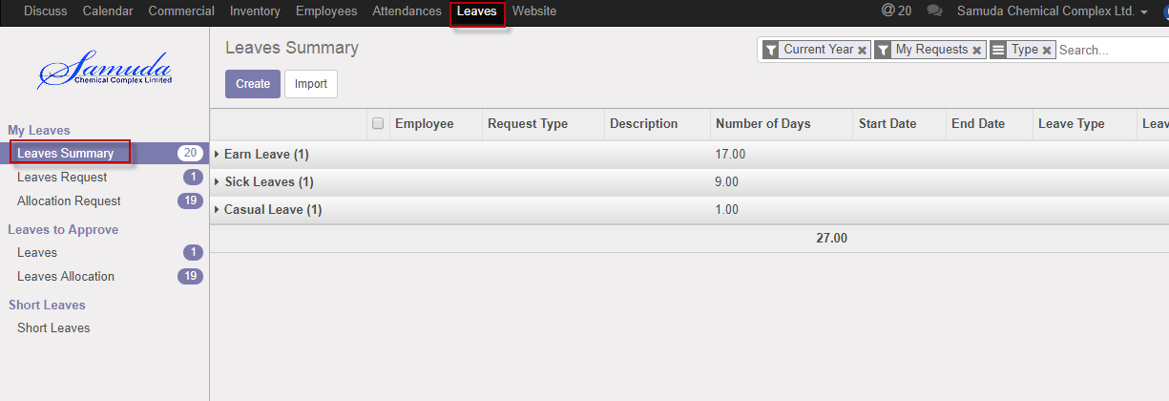

Figure: Leave Summary

## 2.2 Leave Request approval by unit HR

After apply the leave request “Unit HR” will get the notification. Respective Unit HR Can first/final approve the leave request. That’s approve will final approve if no other employee none the set custom chain. Respective Unit HR can update number of leave day(s) before approve.

To see the employee leave request use the menu **Leave ‣ My Leaves ‣ Leaves Request.**



Figure: Leave Request Notification

Unit HR can approve employee’s leave request. Unit HR can see all leave request there **Leave ‣ Leave to approve ‣ Leaves.**

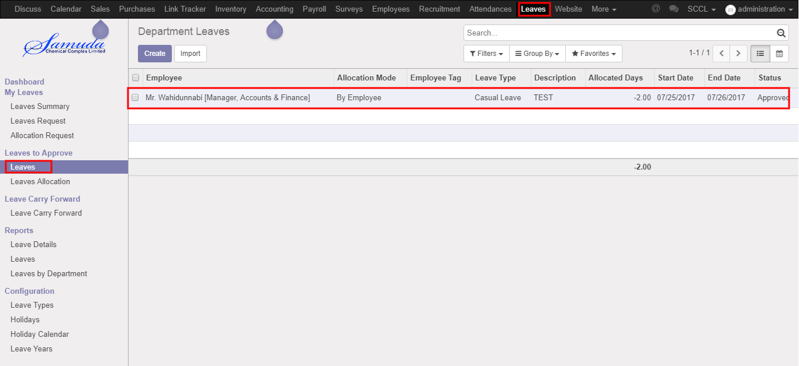

Figure: Leave Request List View

Here Unit HR can first/final approve the leave request by click on **Approve** button. He can update number of leave day(s) before approval.

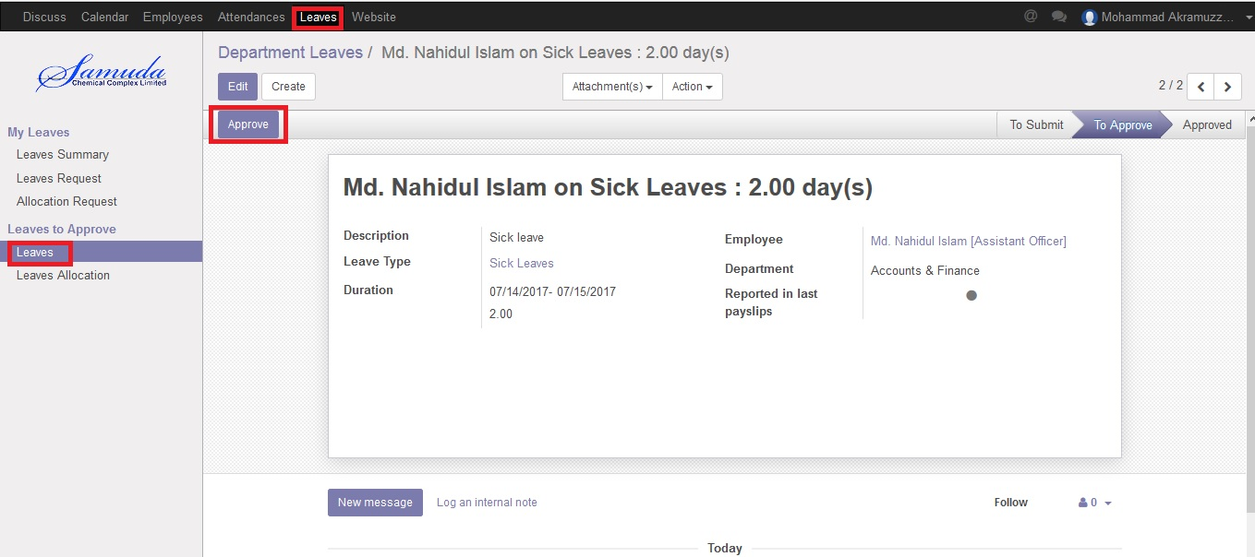

Figure: A Leave Request Approval

Unit HR can refuse leave request by click **Refuse** Button.

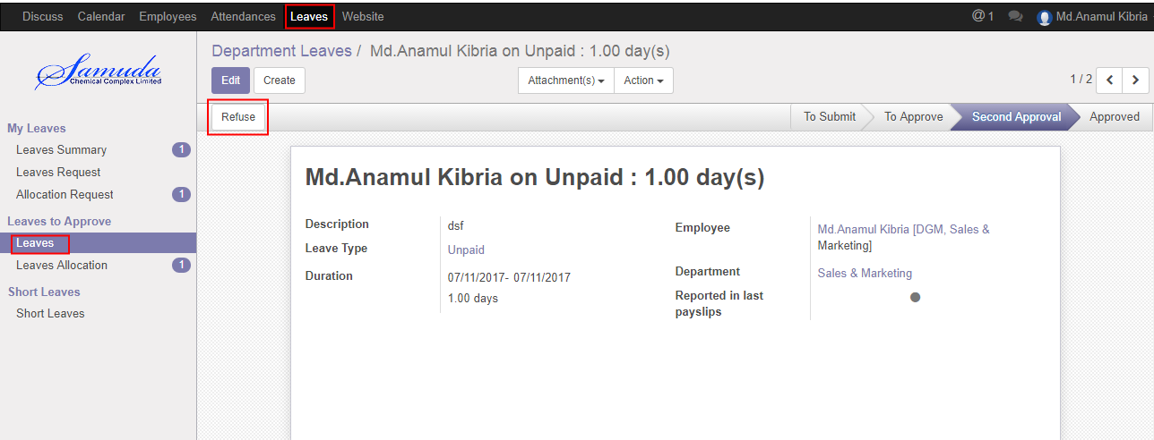

Figure: A Leave Request Refuse

# 3. Leave Allocation Request Approval by Unit HR

Unit HR will approve leave allocation request if He/she exist in Approval chain.

## 3.1 Leave Allocation Request Approval by Unit HR

After apply the leave allocation request “Unit HR” will get the notification. Unit HR can update number of leave day(s) before approval..

Unit HR can first/final approve the leave allocation request by click on **Approve** button.

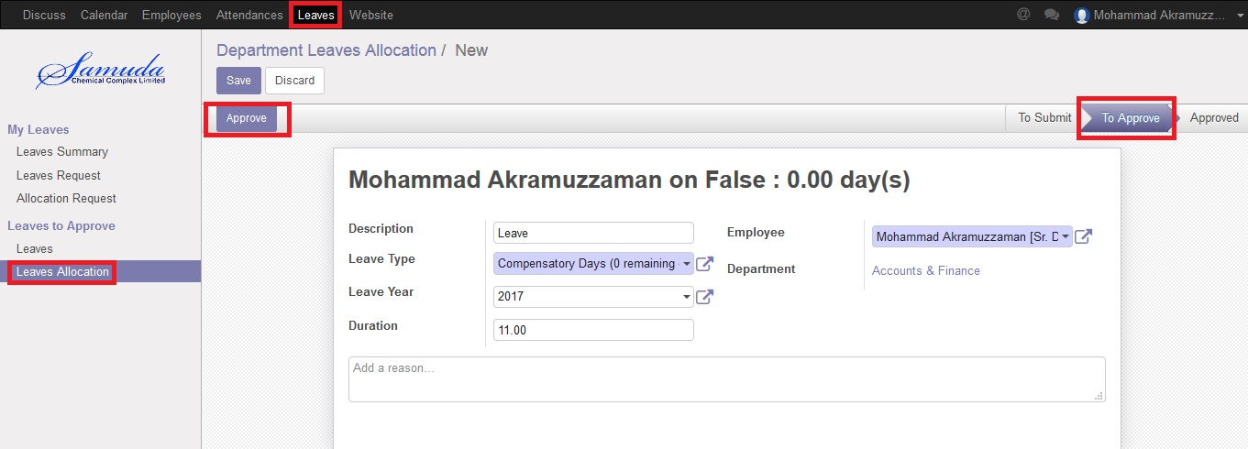

Figure: Leave Allocation Request Approval

# 4. Short Leave Request

Unit HR is capable to his/her own short leave request & will create short leave on behalf of under his employee. He/she will approve short leave request under his all employee against.

## 4.1 Create Short Leave Request

Short Leave is for urgent private business that occurs without notice. Short leave can be used for an emergency purpose. For create a short leave request, we have to go **Leaves** menu then create a Short Leave Request.

To create new Short Leave Request, Using the menu **Leave ‣ Short Leaves ‣ Short Leaves** click **Create**.

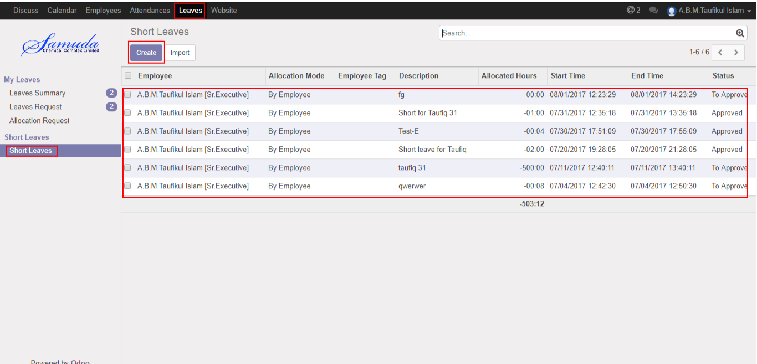

Figure: Short Leaves List View

You can set the following information:-

**Description:** Enter some description.

**Duration:** Select duration of leave.

After entering the Short Leave Request information click **save**.

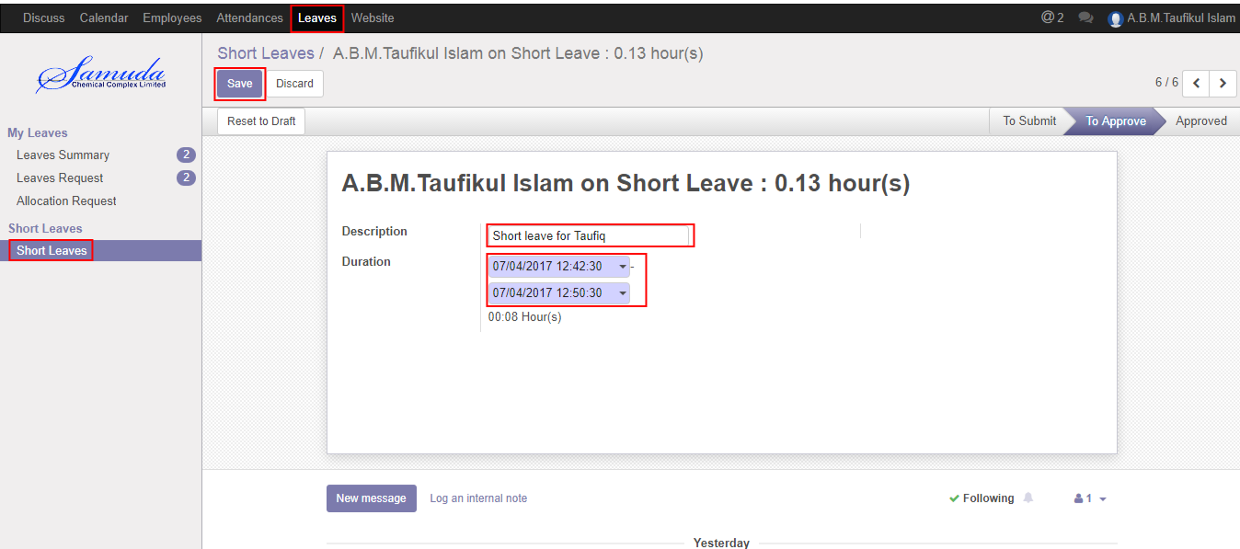

Figure: Create a Short Leave Request

After apply the Short leave request respective manager will get the notification. Manger can approve or Refuse the short leave request. He can update number of Hour’s before approval. Unit HR Can Approve or Refuse the short leave request. After that requested short leave will finally approve.

# 5. Short Leave Request Approval by Unit HR

Unit HR will approve Short leave request if He/she exist in Approval chain.

## 5.1 Short Leave Approval Request by Unit HR

After apply the short leave request Unit HR will get the notification. Unit HR Can first/final approve the leave request. That’s approve will final approve if no other employee none the set custom chain. He/she can update number of leave day(s) before approve.

To see the employee short leave request use the menu **Leave ‣ Short leave**

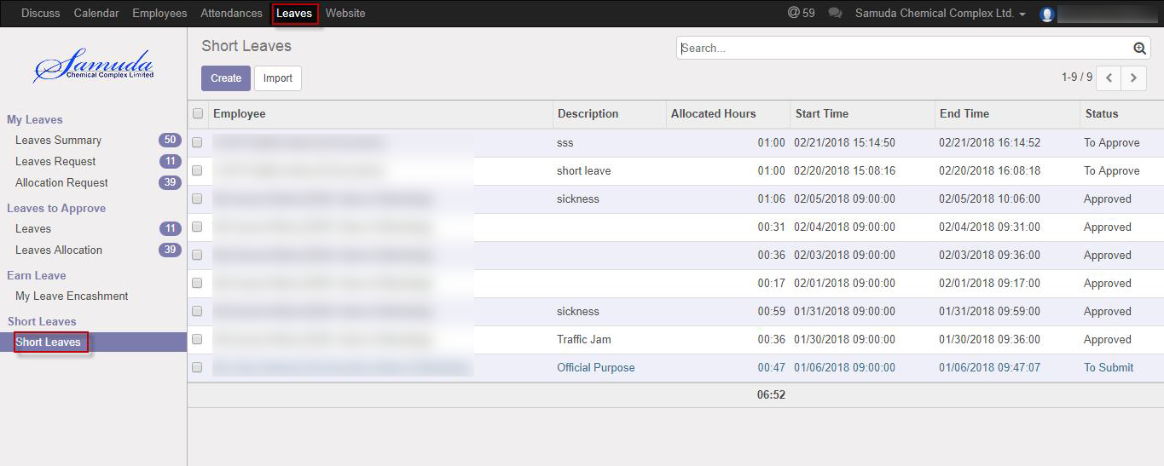

Figure: Short Leave Request list view

Unit HR can approve employee’s short leave request. He/she can see all leave request there **Leaves ‣ Short leave**

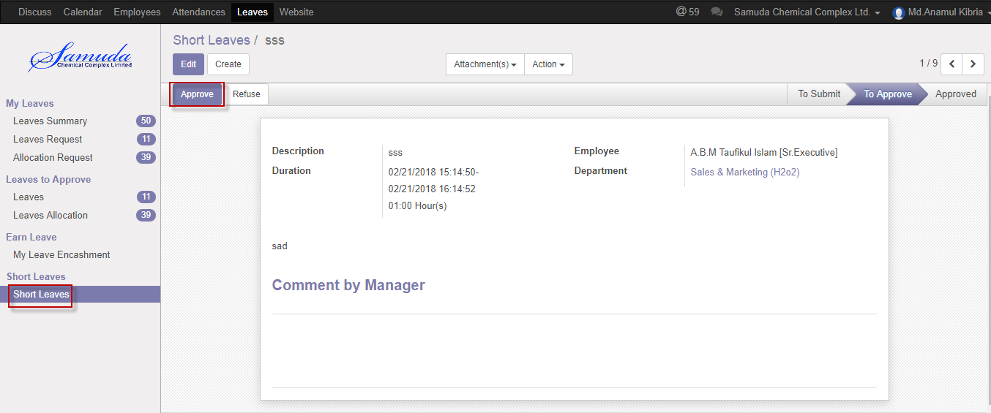

Figure: Short Leave Request First Approval

Unit HR can first/final approve the leave request by click on **Approve** button.

Unit HR can refuse short leave request by click **Refuse** Button.

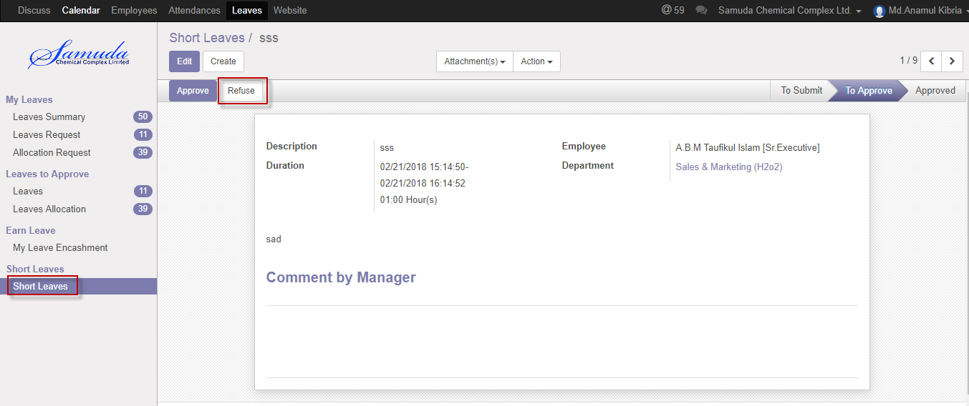

Figure: Short Leave Request Refuse

# 6. Attendance

Unit HR is capable to his/her own Manual attendance request and he also is capable to on behalf of employee request. He/she will approve Manual attendance request under his all employee against.

## 6.1 Create Manual Attendance

Sometimes employees work outside of office for this reason he/her can’t sign in or sign out. To solve this problem employee can request to Respective manager by this manual attendance process.

We can create manual attendance using the menu **Attendances ‣ Manual Attendances ‣ My Attendances** and click **Create.**

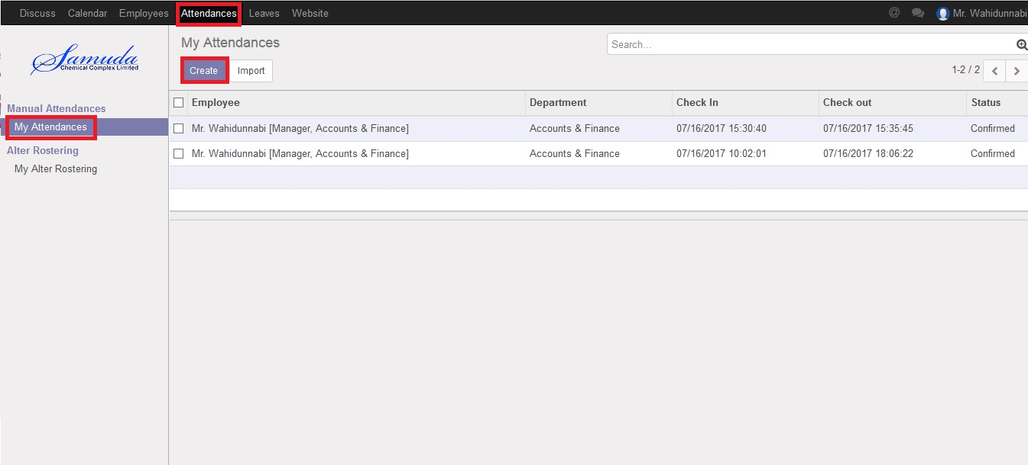

Figure: Manual Attendance List view

We need to set the following:-

**Employee**: An employee name.

**Department**: Select a department.

**Sign Type:** Select a sign type.

**Check In:** Work starting time.

**Check Out:** Work closing time.

After entering all information click **Save**.

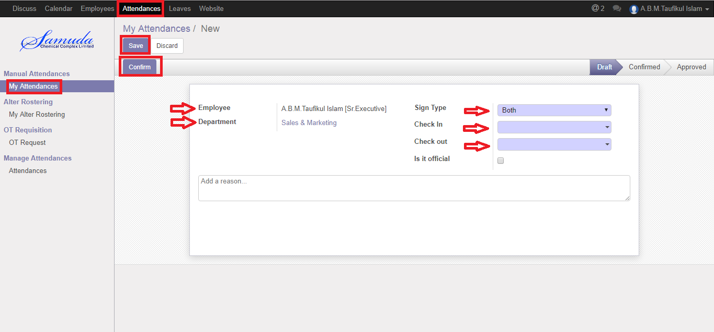

Figure: Create a Manual Attendance

After apply the Manual attendance respective will get the notification.

# 7. Manual Attendance Request Approval by Unit HR

Unit HR will approve manual attendance request if He/she exist in Approval chain.

## 7.1 Pending Manual Attendance

Unit HR can see all of employee pending manual attendance request.

Using the menu **Attendance ‣ Pending Approvals**.

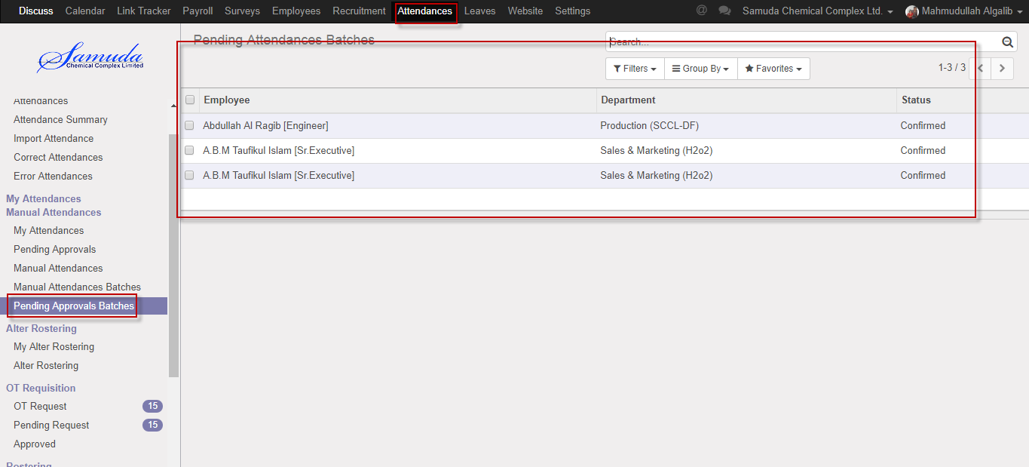

Figure: Manual Attendance Pending Approval List View

## 7.2 Approval Manual Attendance Request by Unit HR

After apply the manual attendance request “HR unit” will get the notification. He can approve the manual attendance request.

To see the employee manual attendance request use the menu **Attendance ‣ Pending Approvals**. Here he can first/final approve the manual attendance request by click on **Approve** button.

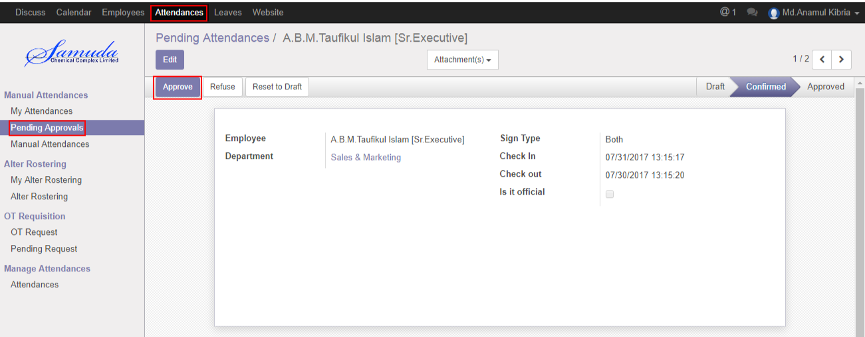

Figure: Manual Attendance Request Approval

He can refuse manual attendance request by click **Refuse** Button.

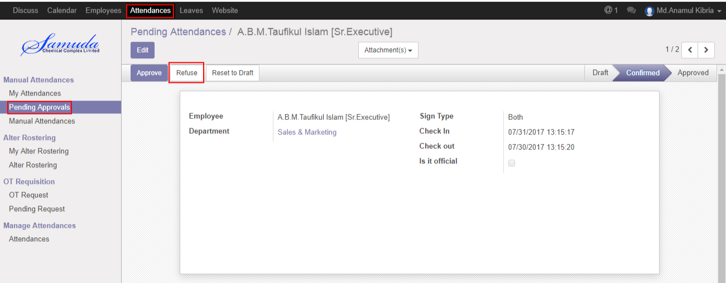

Figure: A Manual Attendance Request Refuse

## 7.3 Create Alter Rostering

Sometimes employees want to change his/her shifting and they want to request Manager . For solving this problem employee can request to Manager by this Alter Rostering process.

Unit HR is capable to his/her own Alter rostering request and on behalf of employee against.

We can create alter rostering using the menu **Attendances ‣ Alter Rostering ‣ My Alter Rostering** click **Create.**

You need to set the following:-

**Employee**: An employee name.

**Alter Date:** A date for attendance.

**Duty Start:** A work stating time.

**Duty End:** A work closing time.

**OT Start:** A work over stating time.

**OT End:** A work over closing time.

After entering the alter rostering information click **Save**.

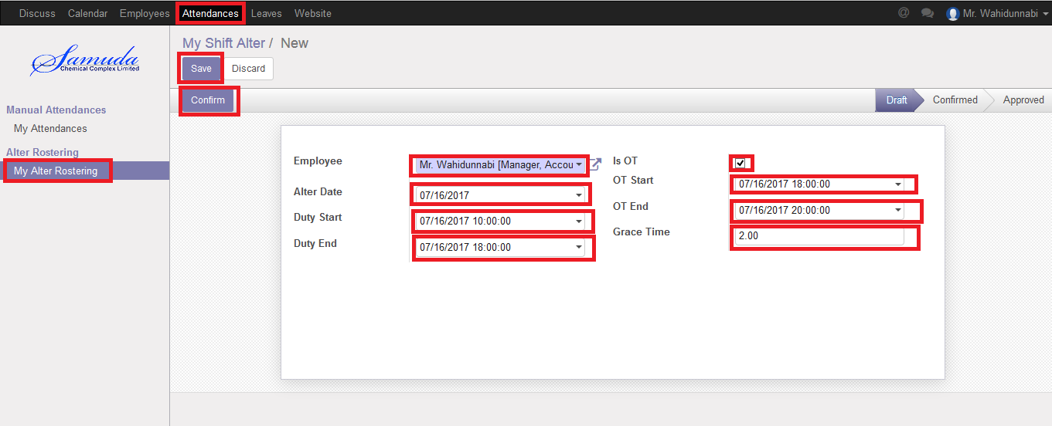

Figure: Create a Alter Rostering

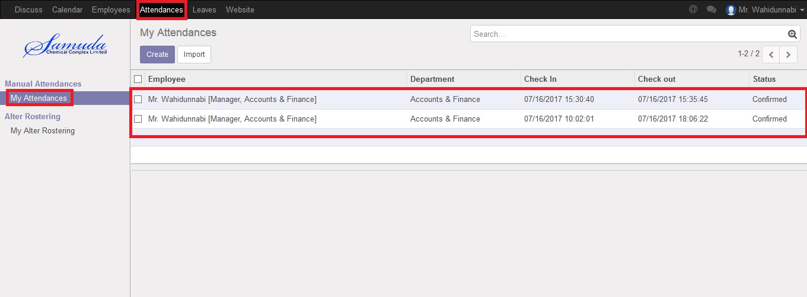

Figure: Alter Rostering Status

## 7.4 Approval Alter rostering Request by HR unit

After apply the Alter roster request “Unit HR” will get the notification. Unit HR can approve the Alter roster request.

To see the employee Alter roster request use the menu **Attendance ‣ Alter roster**. Here Unit HR can first/final approve the Alter roster request by click on **Approve** button.

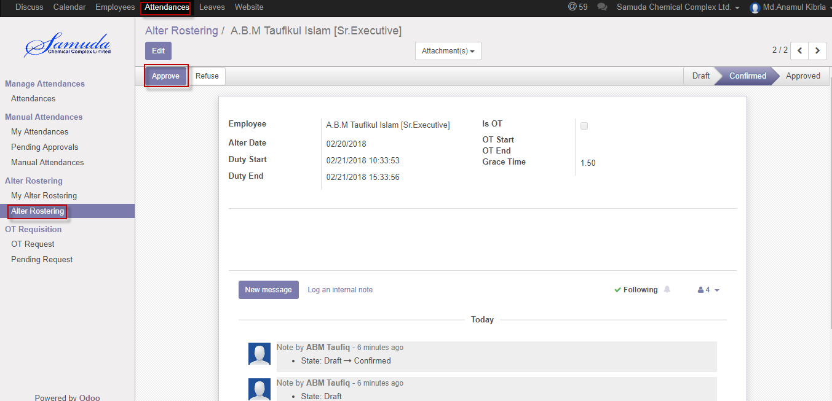

Figure: Alter roster request Approval

He can refuse Alter roster request by click **Refuse** Button.

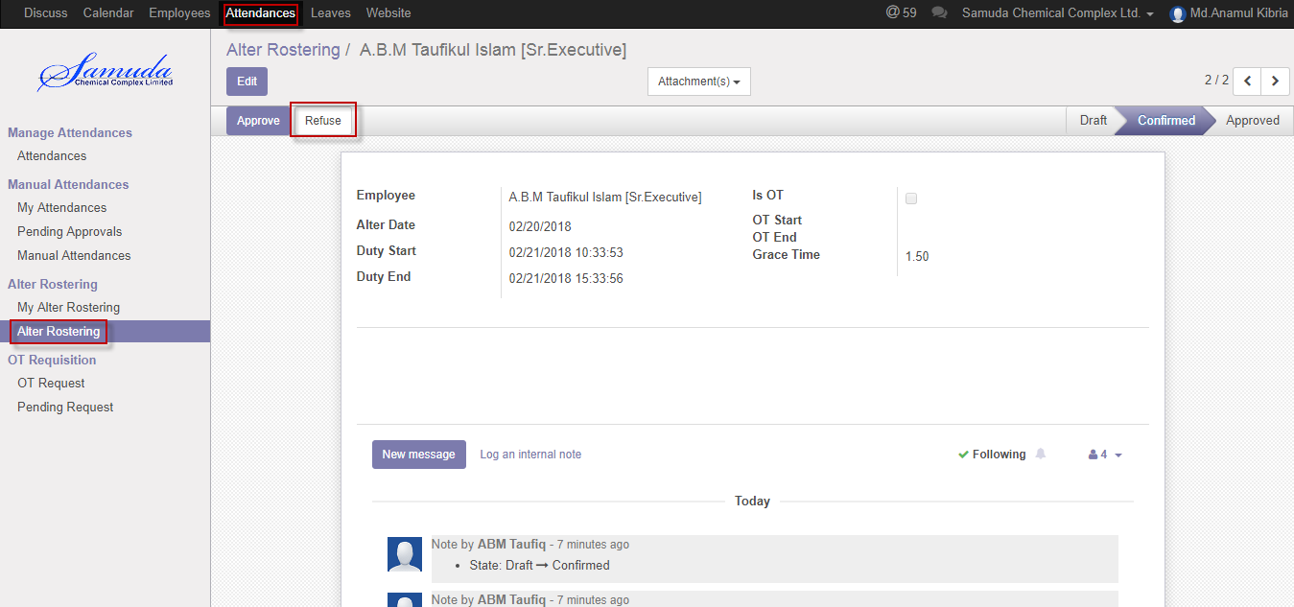

Figure: A alter roster Request Refuse

# 8. OT Requisition

HR unit is capable to his/her own OT requisition request and on behalf of employee against. He/she will approve OT requisition request under his all employee against.

## 8.1 Create a OT Request

Sometimes employees want to extra overtime work that’s why he/she have to request Manager. To solve this problem employee can request to Manager by this OT Requisition process.

We can create OT Request using the menu **Attendances ‣ OT Requisition ‣ OT Request** and click **Create.**

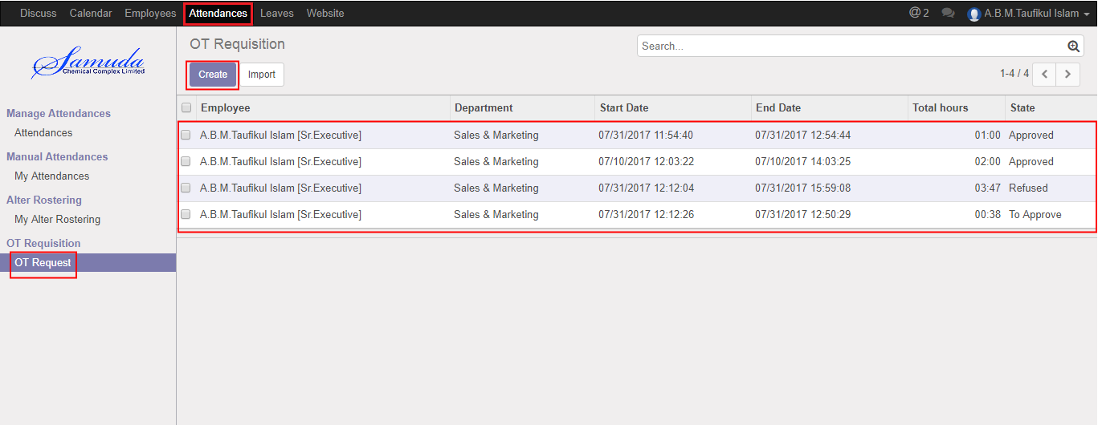

Figure: OT Request List view

We need to set the following:-

**Employee**: An employee name.

**Department**: Automatically select a department.

**Start Date:** Work starting time.

**End Date:** Work closing time.

After entering all information click **Save**.

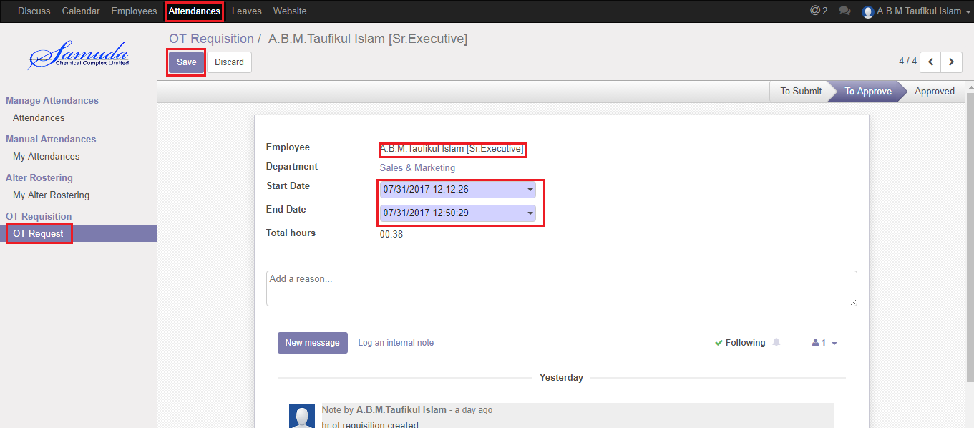

Figure: Create a OT Request

# 9. OT Request Approval by Unit HR

Unit HR will approve manual attendance request if He/she exist in Approval chain.

## 9.1 OT Approval Request by Unit HR

After apply the OT request Unit HR will get the notification. Unit HR Can first/final approve the OT request. That’s approve will final approve if no other employee none the set custom chain. To see the OT pending request use the menu **Attendance ‣ OT requisition>Pending request**

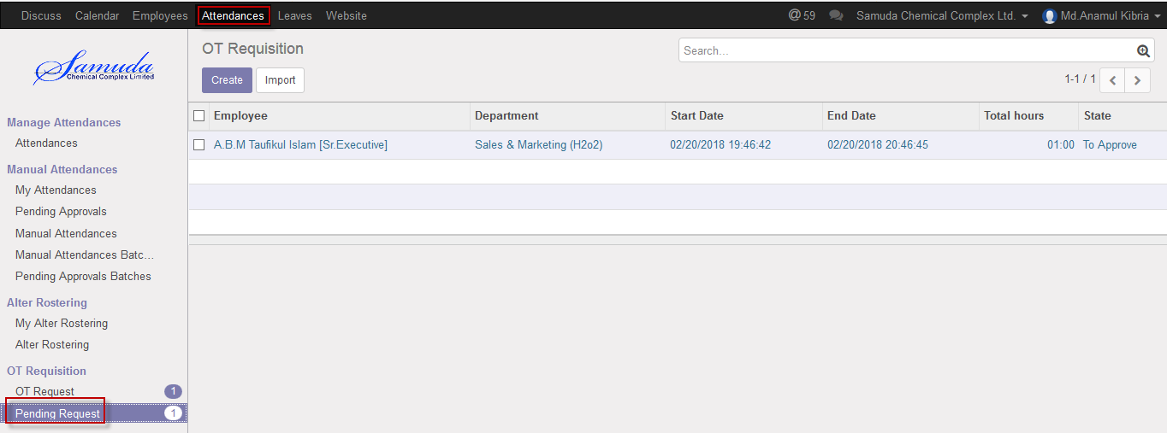

Figure: Pending OT Request list view

Unit HR can approve employee’s OT request. Unit HR can see all OT request there **Attendance ‣ OT requisition>>Pending request**

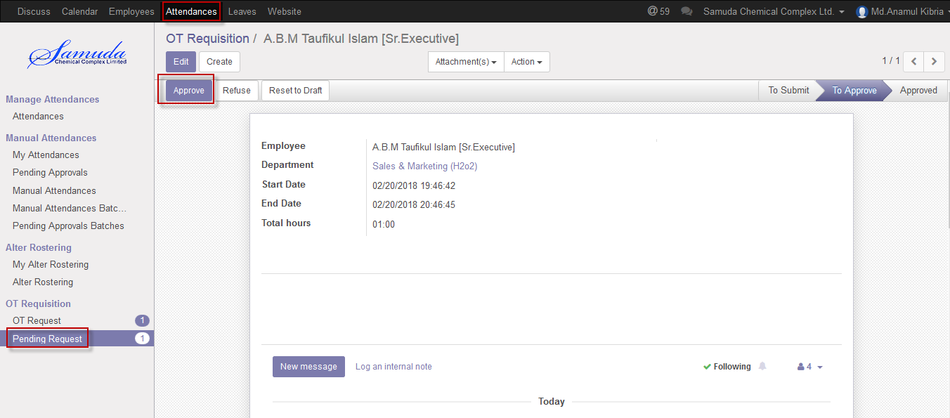

Figure: OT Request Approval

Here Unit HR can first/final approve the OT request by click on **Approve** button. He can update OT request before approval.

Unit HR can refuse OT request by click **Refuse** Button.

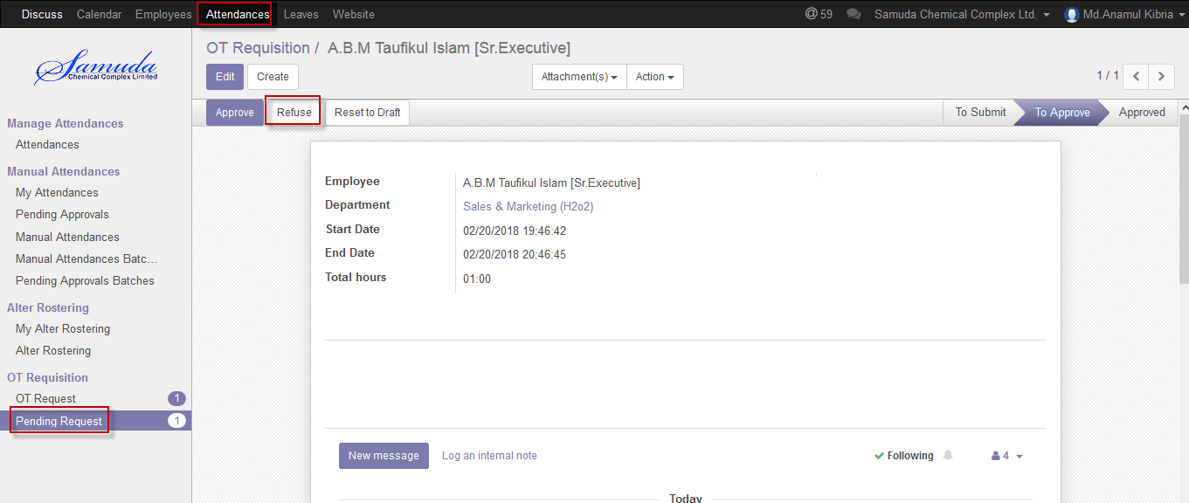

Figure: OT Request Refuse

# 10. Configuration by HR Manager

Some configuration requires for HR module, HR manager can configure this.

## 10.1 Create Leave type configure by HR Manager

Leave type require for employee leave application, several type leave are existent, Casual leave, Sick leave, earn leave, compensatory leave etc.

We can create leave type using the menu **Leaves ‣ Configuration ‣ leave types** and click **Create.**

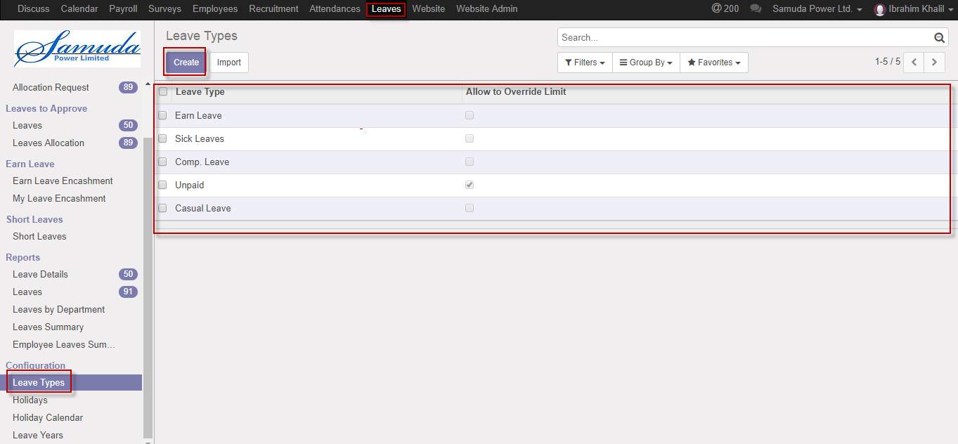

Figure: Leave type List view

We need to set the following:-

**Leave type**: A leave type name.

**Carry forward this leave:** Checked or Unchecked.

**Active:** Checked or Unchecked.

After entering all information click **Save**.

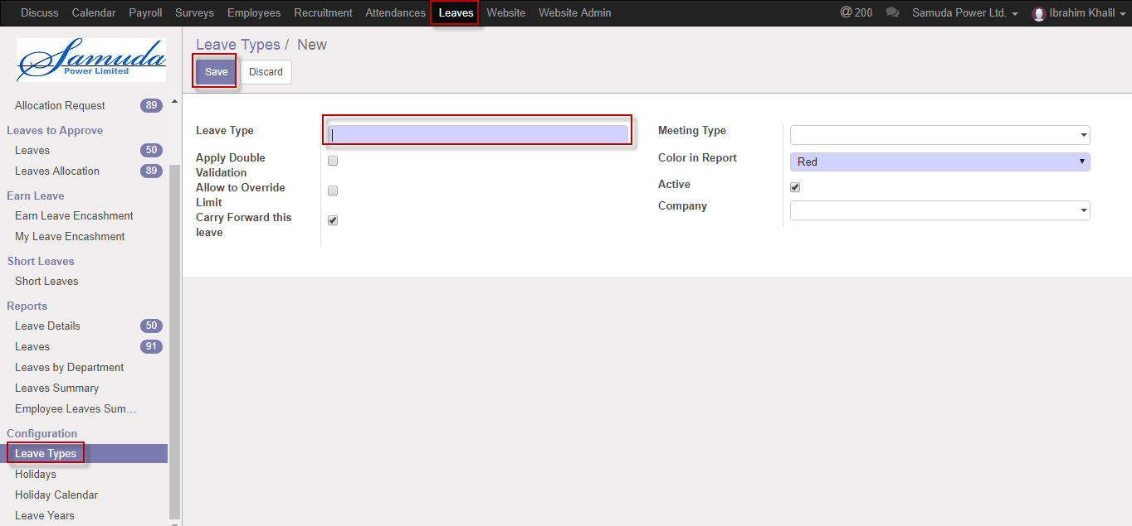

Figure: Create a leave type

## 10.2 Create Holidays configure by HR Manager

Holidays can set by HR manager, all public holidays can configure in this form and also Operating unit can set in this form.

We can create Holidays using the menu **Leaves ‣ Configuration ‣ Holidays** and click **Create.**

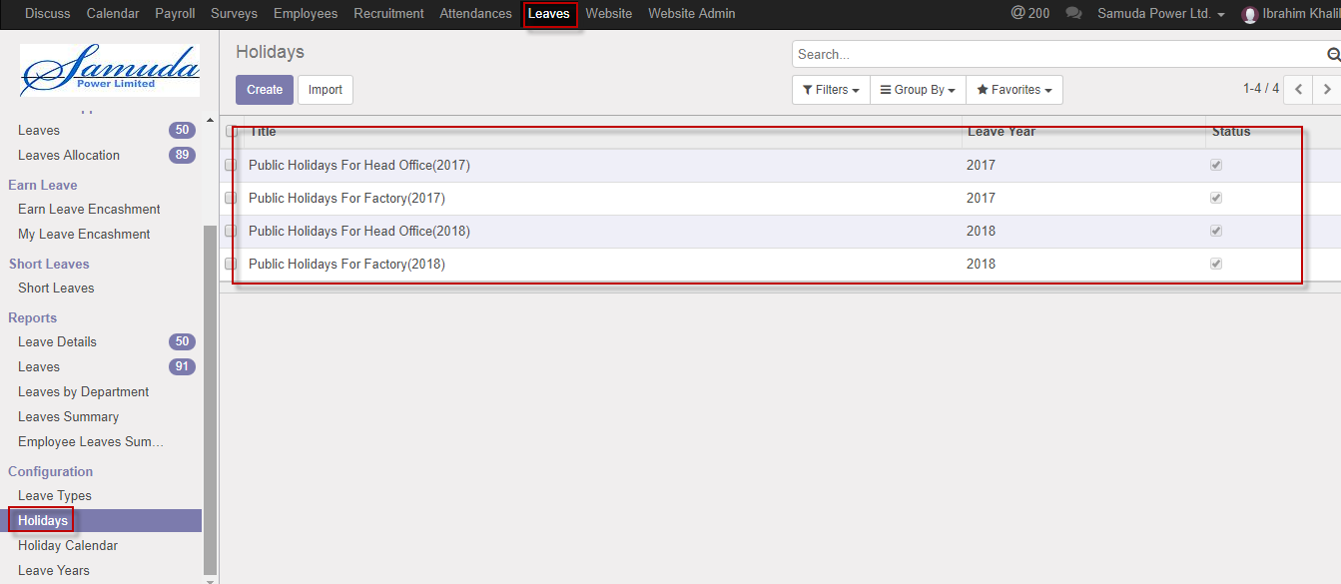

Figure: Holidays List view

We need to set the following:-

**Title**: A holiday title name.

**Leave year:** Select leave year.

**Name:** Enter holiday name.

**Date:** Select holiday Date.

**Operating unit:** Select operating unit, which operating unit against holiday will applicable.it will be single or multiple.

After entering all information click **Save & Generate**.

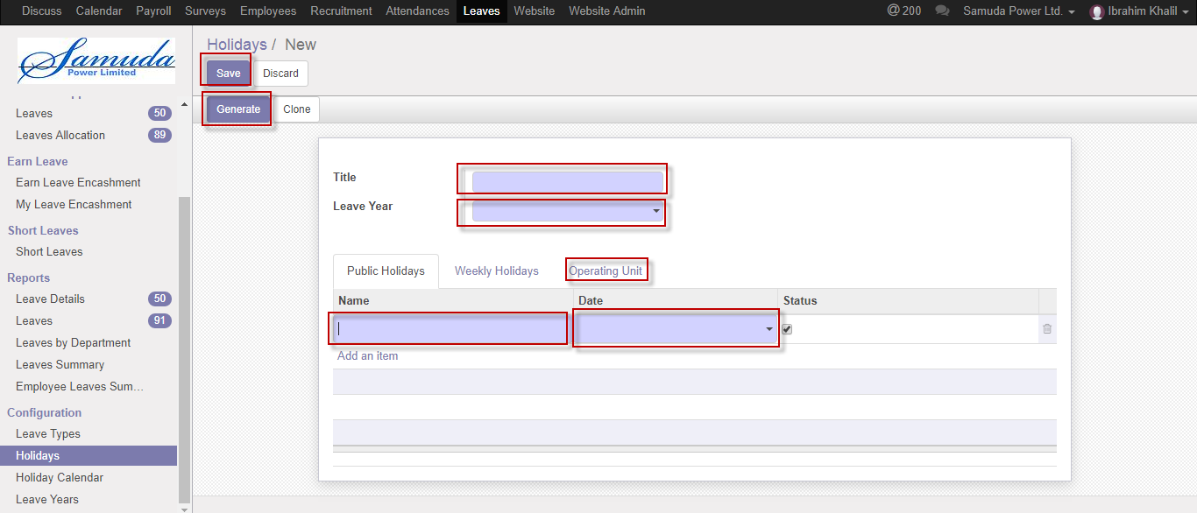

Figure: Create a Holiday

## 10.3 Create Holiday Calendar configure by HR Manager

Holiday calendar can set by HR manager, all public holiday calendar can configure in this form .We can create Holiday calendar using the menu **Leaves ‣ Configuration ‣ Holiday calendar** and click **Create.**

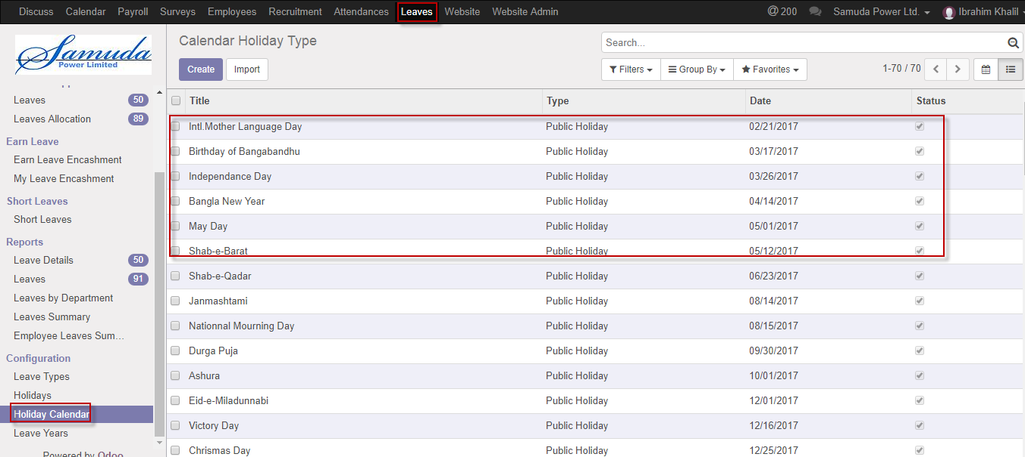

Figure: Holiday calendar List view

We need to set the following:-

**Title**: Enter a holiday calendar name.

**Type:** Select type.

**Date:** Select Date.

**Color:** Enter a color name

After entering all information click **Save**.

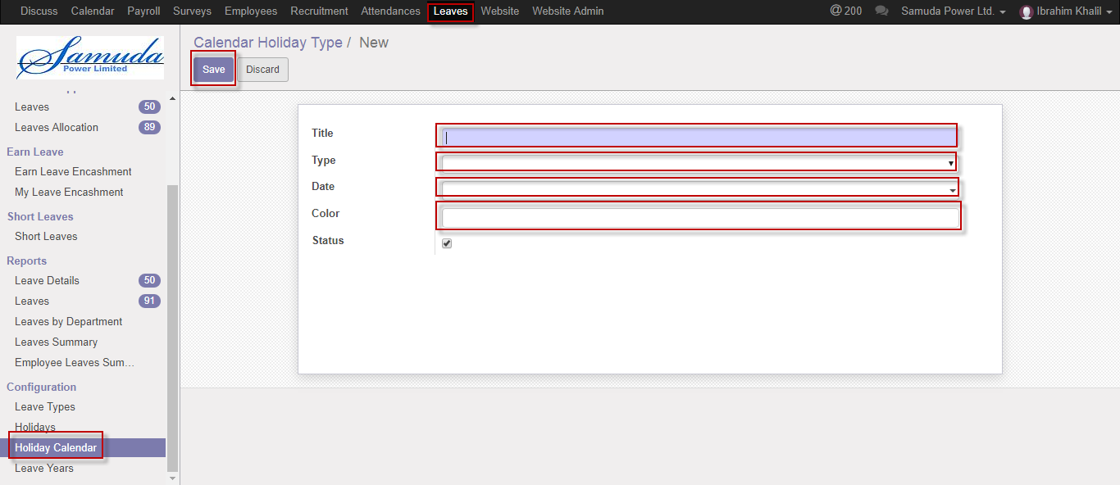

Figure: Create a Holiday calendar

## 10.4 Create Leave years configure by HR Manager

Leave year require for employee leave application

We can create leave year using the menu **Leaves ‣ Configuration ‣ leave year** and click **Create.**

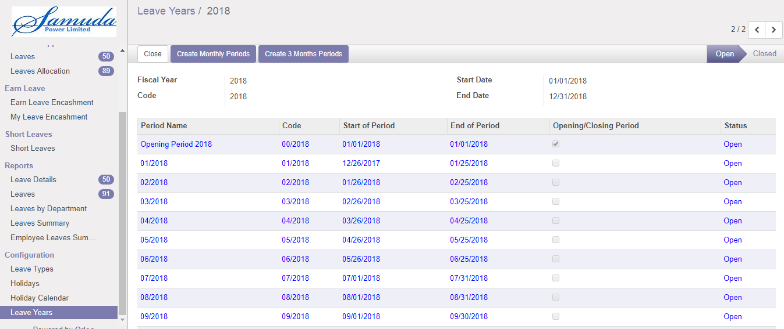

Figure: Leave year List view

We need to set the following:-

**Period name**: Enter period name

**Code:** Enter code.

**Start of period:** Select start of period.

**End of period:** Select End of period.

After entering all information click **Save & Generate**.

## 10.5 Create Attendance login grace time configure by HR Manager

Company can provide some grace time for Employee login time, here is the setup form.

We can create Login grace time using the menu **Attendances ‣ Configuration ‣ Login grace time** and click **Create.**

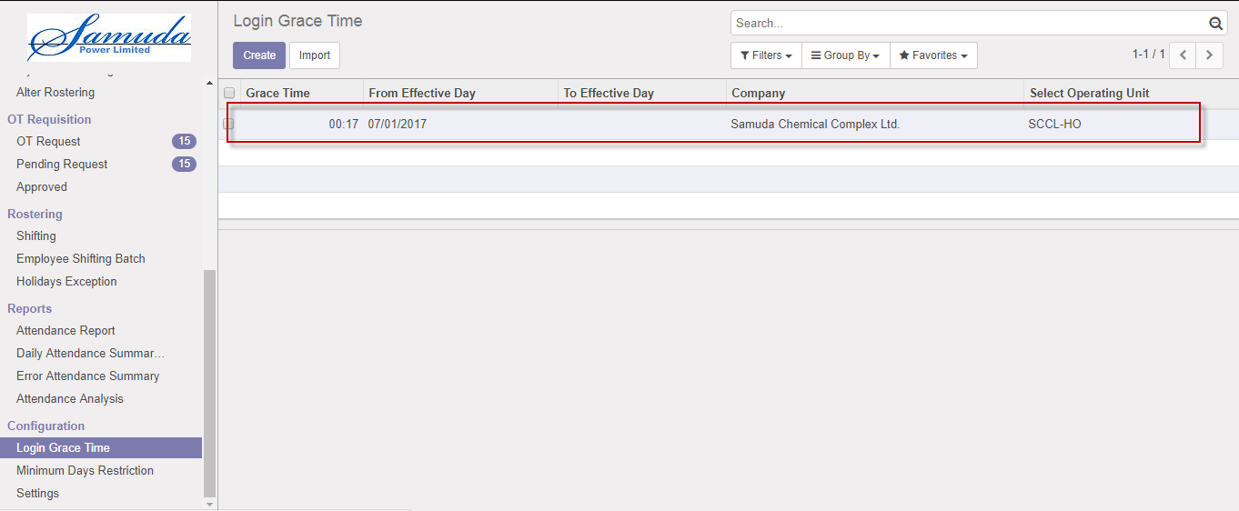

Figure: Login grace time List view

We need to set the following:-

**Grace time**: Enter grace time.

**From effective day:** Select from effective day.

**Company:** Select a company.

**Select operating unit:** Select an operating unit

After entering all information click **Save**.

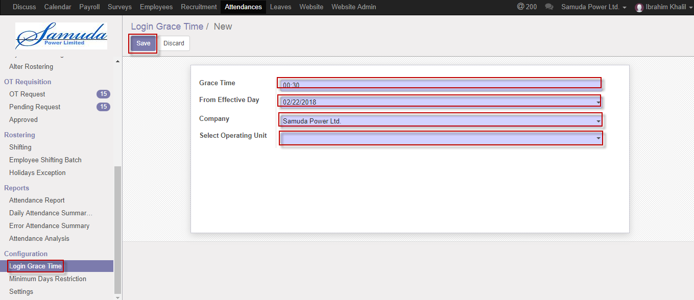

Figure: Create a Login grace time

## 10.6 Create Loan types configure by HR Manager

Loan types require for employee loan application, several type loan are existent, Personal loan, Home loan etc.

We can create loan type using the menu **Employees ‣ Configuration ‣ Loan types** and click **Create.**

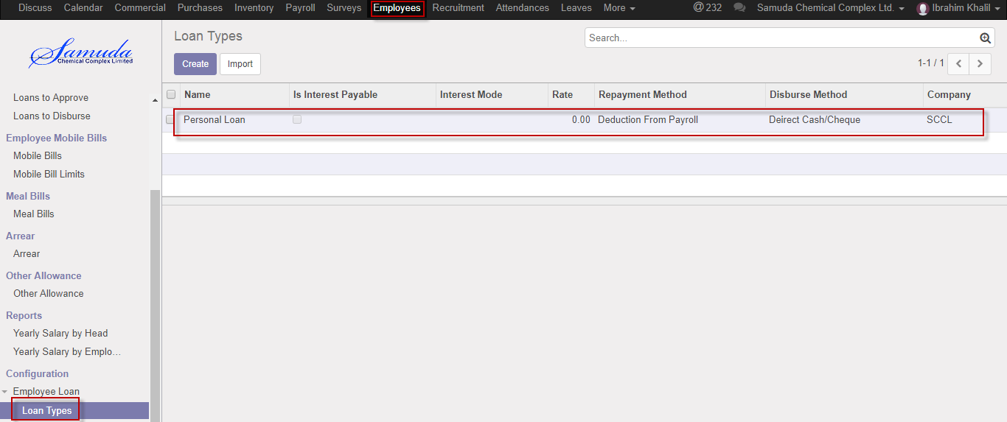

Figure: Loan type List view

We need to set the following:-

**Name**: Enter a name.

**Code:** Enter code.

**Interest account:** Select interest account.

**Repayment method:** Select repayment**.**

**Disburse method:** Select disburse method.

After entering all information click **Save**.

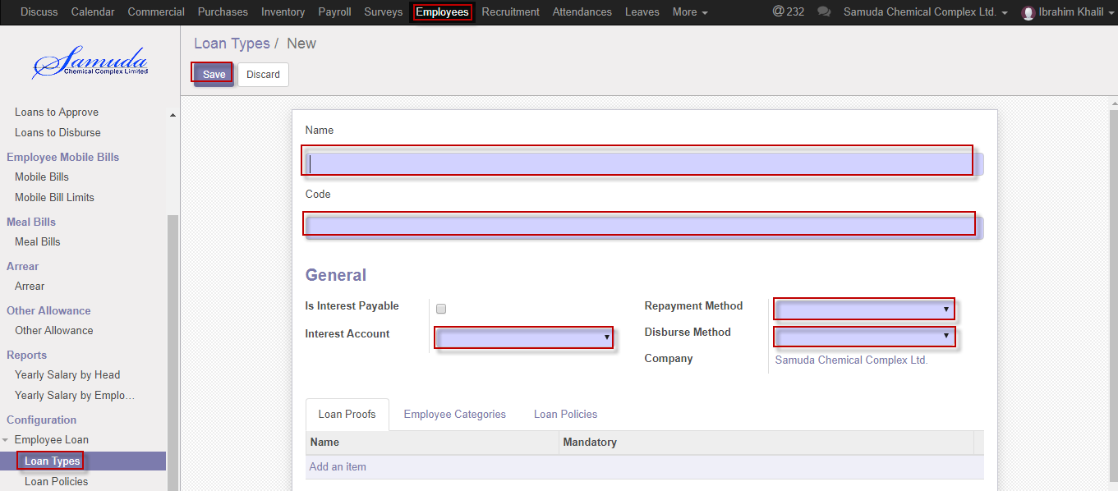

Figure: Create a loan type

## 10.7 Create Loan policies configure by HR Manager

Loan policies require for employee loan application, several type loan policies are existent. We can create loan policies using the menu **Employees ‣ Configuration ‣ Loan policies** and click **Create.**

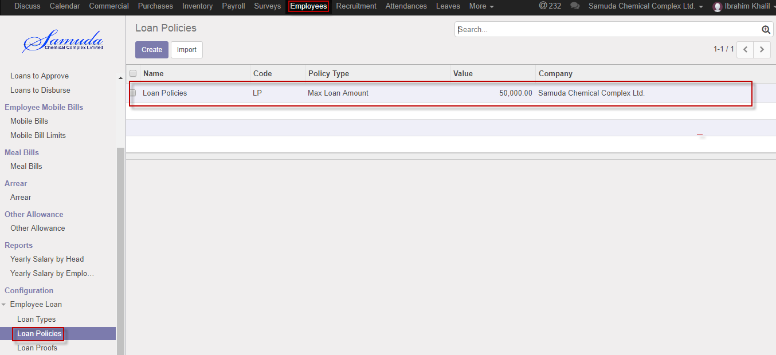

Figure: Loan policies List view

We need to set the following:-

**Name**: Enter a name.

**Code:** Enter code.

**Policy type:** Select policy type.

**Basis:** Select basis**.**

**Value:** Select value.

**Employee tags:** Which operating unit under this policies.

After entering all information click **Save**.

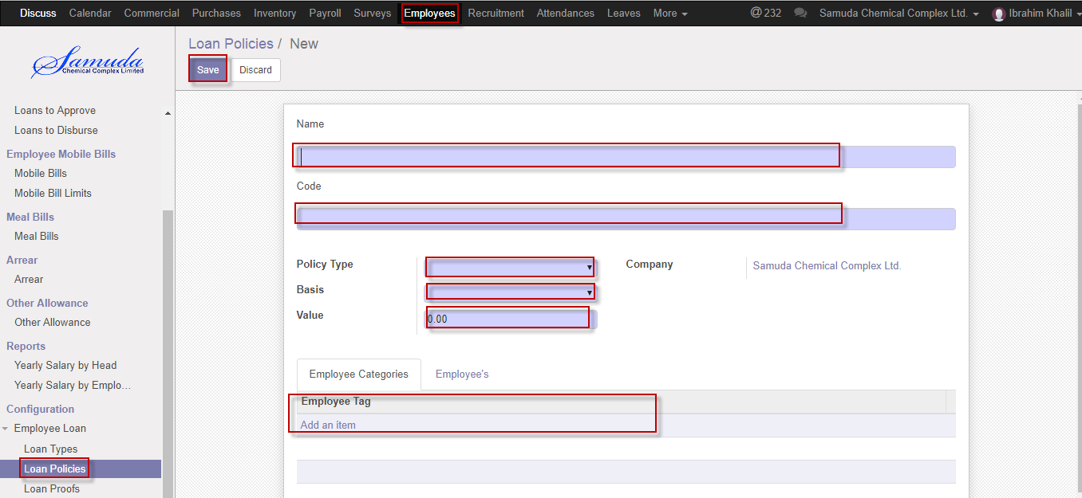

Figure: Create Loan policies

## 10.8 Create Loan proofs configure by HR Manager

Loan proofs require for employee loan application. What kind of document are needed for the loan application that’s the mean. We can create loan proofs using the menu **Employees ‣ Configuration ‣ Loan proofs** and click **Create.**

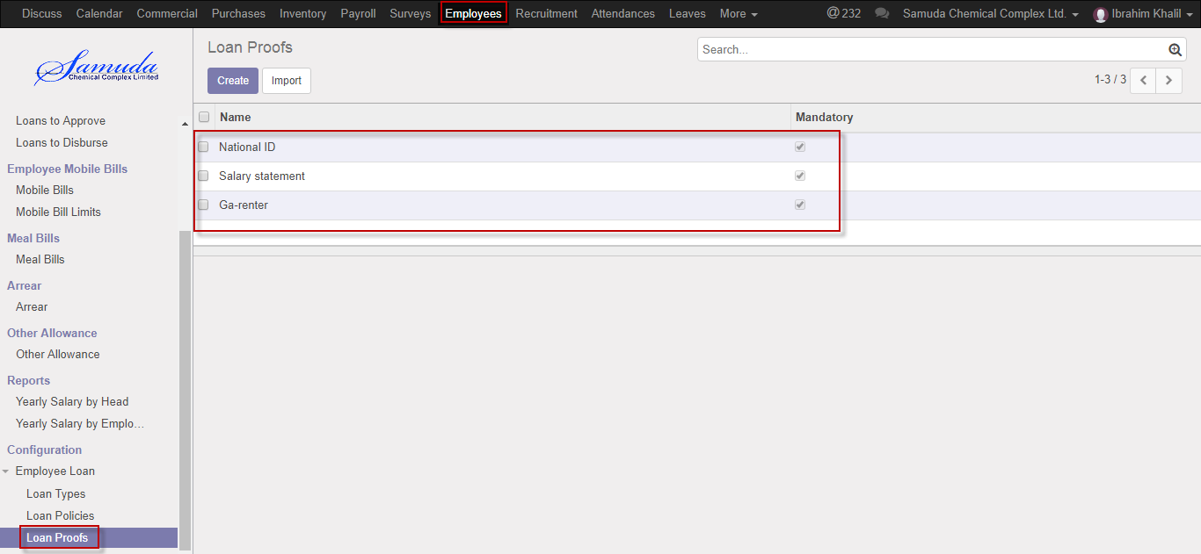

Figure: Loan proofs List view

We need to set the following:-

**Name**: Enter a name.

**Code:** Enter code.

**Policy type:** Select policy type.

**Basis:** Select basis**.**

**Value:** Select value.

**Employee tags:** Which operating unit under this policies.

After entering all information click **Save**.



Figure: Create Loan policies

# 11. Leave request by HR manager

HR manager is capable to his/her own leave request and on behalf of employee. He/she will approve leave request under his all employee against.

## 11.1 Create Leave Request

For create a leave request we have to go leave menu then create a leave request.

Using the menu **Leave ‣ My Leaves ‣ Leave Request** click **Calendar** button.



**Fig:** Leave Calendar View

Also we can see using the menu **Leave ‣ My Leaves ‣ Leave Request** click **List** button.



Figure**:** Leave List View

To create new Leave Request, Using the menu **Leave ‣ My Leaves ‣ Leave Request** click **Create**.



You can set the following information:-

**Description:** Enter some description.

**Leave Type:** Select a leave type.

**Duration:** Select duration of leave.

After entering the Leave Request information click **Save**.



Figure: Create a Leave Request

After apply the leave request respective “HR manger” will get the notification. HR Manager approve the leave request. He can update number of leave day(s) before approval. . He Can Approve or Refuse the leave request. After that requested leave will finally approve.



Figure: Leave Request Notification

## 11.2 Create Leave Allocation Request by HR manager

HR manager is capable to his/her own leave allocation request and he/she will approve leave allocation request under his all employee against.

For create a leave allocation request we have to go leave menu then create an allocation request.

Using the menu **Leave ‣ My Leaves ‣ Allocation Request** click **Create**.

Figure: A Leave Allocation Request

After apply the leave allocation request respective “HR manager” will get the notification. He can approve or Refuse the leave allocation request. He can update number of day(s) before approval. Manager Can Approve or Refuse the leave allocation request. After that requested leave allocation will finally approve.

# 12. Leave Request Approval by HR manager

HR manager will approve leave if He/she exists in Approval chain.

## 12.1 Leave Summary

Only approver hierarchy user can see all of employee leave Summary/Leave allocation/Leave request, if He/she exist in set custom chain level. This will set to employee profile form.

Using the menu **Leave ‣ My Leaves ‣ Leave Summary**.



Figure: Leave Summary

## 12.2 Leave Request approval by HR manager

After apply the leave request “HR manager” will get the notification. Respective HR manager Can first/final approve the leave request. That’s approve will final approve if no other employee none the set custom chain. Respective HR manager can update number of leave day(s) before approve.

To see the employee leave request use the menu **Leave ‣ My Leaves ‣ Leaves Request.**



Figure: Leave Request Notification

HR manager can approve employee’s leave request.HR manager can see all leave request there **Leave ‣ Leave to approve ‣ Leaves.**



Figure: Leave Request List View

Here HR manager can first/final approve the leave request by click on **Approve** button. He can update number of leave day(s) before approval.



Figure: A Leave Request Approval

HR manager can refuse leave request by click **Refuse** Button.



Figure: A Leave Request Refuse

# 13. Leave Allocation Request Approval by HR manager

HR manager will approve leave allocation request if He/she exist in approval chain.

## 13.1 Leave Allocation Request Approval by HR manager

After apply the leave allocation request “HR manager” will get the notification. HR manager can update number of leave day(s) before approval..

HR manager can first/final approve the leave allocation request by click on **Approve** button.



Figure: Leave Allocation Request Approval

# 14. Short Leave Request

HR manager is capable to his/her own short leave request & will create short leave on behalf of under his employee. He/she will approve short leave request under his all employee against.

## 14.1 Create Short Leave Request

Short Leave is for urgent private business that occurs without notice. Short leave can be used for an emergency purpose. For create a short leave request, we have to go **Leaves** menu then create a Short Leave Request.

To create new Short Leave Request, Using the menu **Leave ‣ Short Leaves ‣ Short Leaves** click **Create**.



Figure: Short Leaves List View

You can set the following information:-

**Description:** Enter some description.

**Duration:** Select duration of leave.

After entering the Short Leave Request information click **save**.



Figure: Create a Short Leave Request

After apply the Short leave request respective manager will get the notification. HR Manger can approve or Refuse the short leave request. He can update number of Hour’s before approval. Unit HR Can Approve or Refuse the short leave request. After that requested short leave will finally approve.

# 15. Short Leave Request Approval by HR manager

HR manager will approve Short leave request if He/she exist in Approval chain.

## 15.1 Short Leave Approval Request by HR manager

After apply the short leave request HR manager will get the notification. HR manager Can first/final approve the leave request. That’s approve will final approve if no other employee none the set custom chain. He/she can update number of leave day(s) before approve.

To see the employee short leave request use the menu **Leave ‣ Short leave**

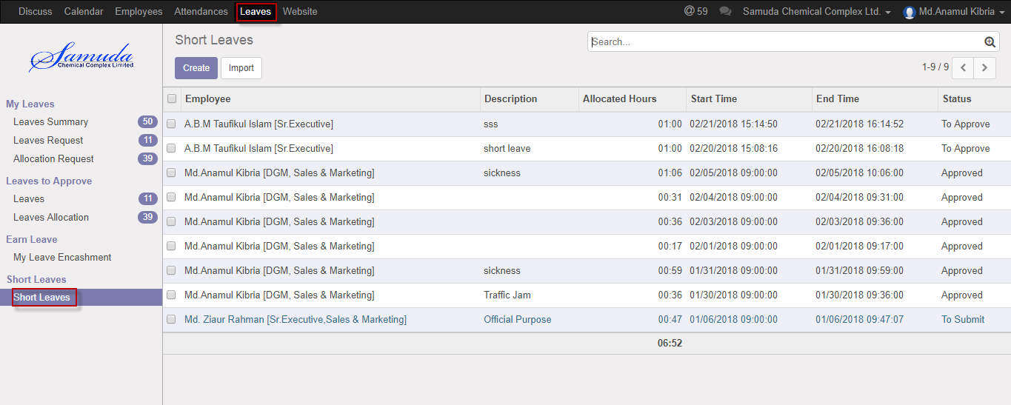

Figure: Short Leave Request list view

HR manager can approve employee’s short leave request. He/she can see all leave request there **Leaves ‣ Short leave**



Figure: Short Leave Request Approval

HR manager can first/final approve the leave request by click on **Approve** button.

HR manager can refuse short leave request by click **Refuse** Button.



Figure: Short Leave Request Refuse

# 16. Attendance for HR manager

HR manager is capable to his/her own Manual attendance request and he also is capable to on behalf of employee request. He/she will approve Manual attendance request under his all employee against.

## 16.1 Create Manual attendances batches for HR manager

Sometimes employees work outside of office for this reason he/her can’t sign in or sign out. To solve this problem employee can request to Respective manager by this manual attendance process.

We can create manual attendance using the menu **Attendances ‣ Manual Attendances ‣ Manual Attendances batches** and click **Create.**

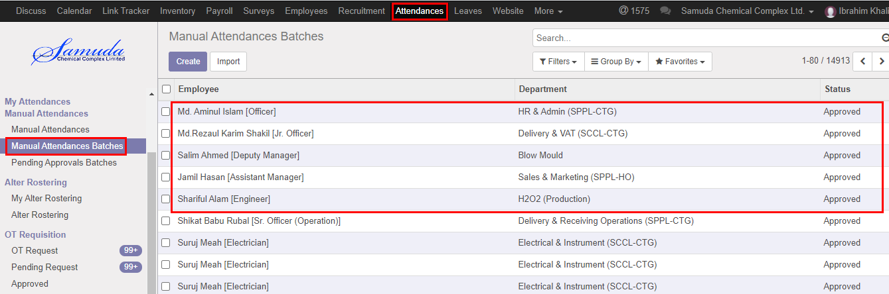

Figure: Manual Attendances batches List view

We need to set the following:-

**Employee**: An employee name.

**Department**: Select a department.

**Sign Type:** Select a sign type.

**Check In:** Work starting time.

**Check Out:** Work closing time.

After entering all information click **Save**.

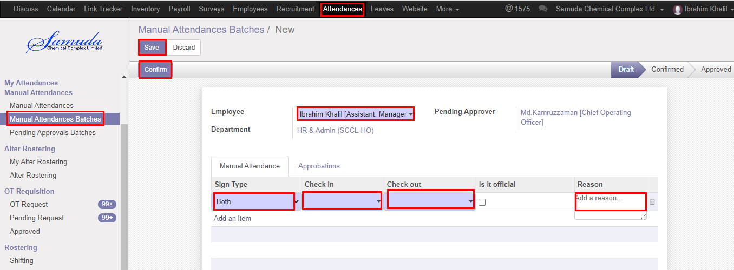

Figure: Create a Manual Attendances batches

After apply the Manual attendance respective will get the notification.

# 17. Manual attendances batches request approval by HR manager

HR manager will approve manual attendances batches request if He/she exist in Approval chain.

## 17.1 Pending Approval batches

HR manager can see all of employee pending manual attendance request.

Using the menu **Attendance ‣ Manual attendances ‣ Pending manual attendances batches**

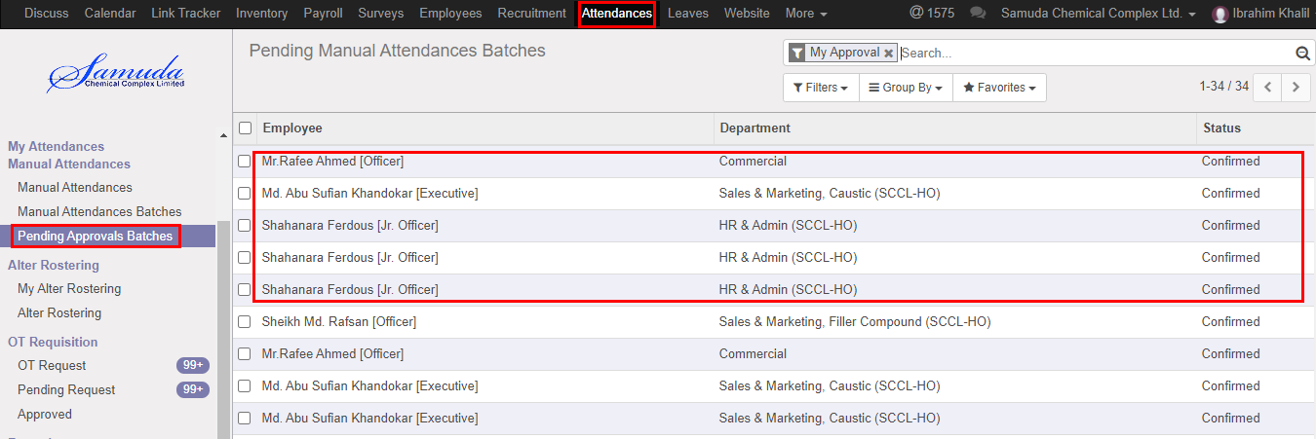

Figure: Pending Approval batches List View

## 17.2 Approval Manual Attendances batches Request by HR manager

After apply the manual attendance batch request “HR manager” will get the notification. He can approve the manual attendances batches request.

To see the employee manual attendance request use the menu **Attendance ‣ Manual attendances ‣ Pending Approvals batches**. Here his can first/final approves the manual attendance batch request by click on **Approve** button.

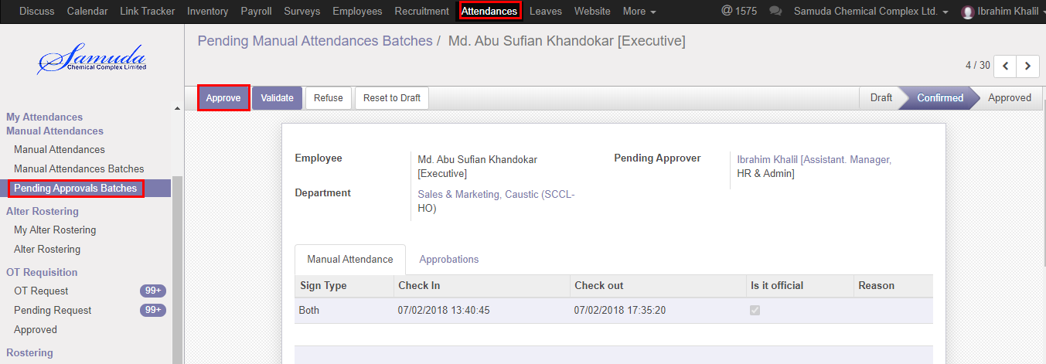

Figure: Manual Attendance batches Request Approval

He can refuse manual attendance request by click **Refuse** Button.

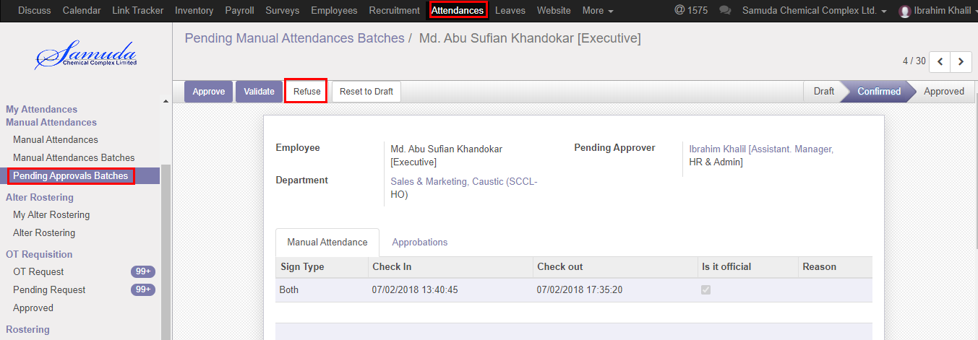

Figure: A Manual attendance batches request refuse

## 17.3 Create Alter Rostering

Sometimes employees want to change his/her shifting and they want to request Manager. For solving this problem employee can request to Manager by this Alter Rostering process.

HR manager is capable to his/her own Alter rostering request and on behalf of employee against.

We can create alter rostering using the menu **Attendances ‣ Alter Rostering ‣ My Alter Rostering** click **Create.**

You need to set the following:-

**Employee**: An employee name.

**Alter Date:** A date for attendance.

**Duty Start:** A work stating time.

**Duty End:** A work closing time.

**OT Start:** A work over stating time.

**OT End:** A work over closing time.

After entering the alter rostering information click **Save**.



Figure: Create a Alter Rostering



Figure: Alter Rostering Status

## 17.4 Approval Alter rostering Request by HR manager

After apply the Alter roster request “HR manager” will get the notification. Unit HR can approve the Alter roster request.

To see the employee Alter roster request use the menu **Attendance ‣ Alter roster**. Here HR manager can first/final approve the Alter roster request by click on **Approve** button.



Figure: Alter roster request Approval

He can refuse Alter roster request by click **Refuse** Button.



Figure: A alter roster Request Refuse

# 18. OT Requisition

HR manager is capable to his/her own OT requisition request and on behalf of employee against. He/she will approve OT requisition request under his all employee against.

## 18.1 Create a OT Request

Sometimes employees want to extra overtime work that’s why he/she have to request Manager. To solve this problem employee can request to Manager by this OT Requisition process.

We can create OT Request using the menu **Attendances ‣ OT Requisition ‣ OT Request** and click **Create.**



Figure: OT Request List view

We need to set the following:-

**Employee**: An employee name.

**Department**: Automatically select a department.

**Start Date:** Work starting time.

**End Date:** Work closing time.

After entering all information click **Save**.



Figure: Create a OT Request

# 19. OT Request Approval by HR manager

Unit HR will approve manual attendance request if He/she exist in Approval chain.

## 19.1 OT Approval Request by HR manager

After apply the OT request HR manager will get the notification. HR manager Can first/final approve the OT request. That’s approve will final approve if no other employee none the set custom chain. To see the OT pending request use the menu **Attendance ‣ OT requisition>Pending request**



Figure: Pending OT Request list view

HR manager can approve employee’s OT request. Unit HR can see all OT request there **Attendance ‣ OT requisition>>Pending request**



Figure: OT Request Approval

Here HR manager can first/final approves the OT request by click on **Approve** button. He can update OT request before approval.

HR manager can refuse OT request by click **Refuse** Button.



Figure: OT Request Refuse

# 20. Employee

HR manager will do new employee Profile creation.

## 20.1 Create Employee

Sometimes New employees are come in company then need to create employee profile here HR manager can create Employee profile & enter all employee information.

We can create employee using the menu **Employee ‣ Employees** and click **Create.**

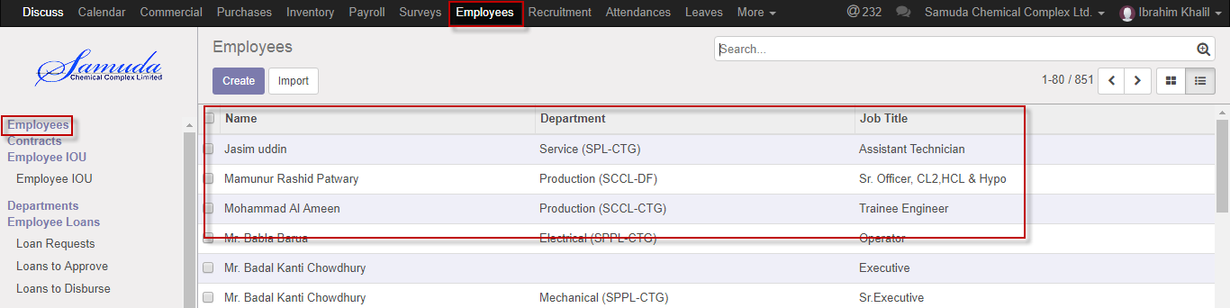

Figure: Employee List view

We need to set the following:-

**Employee**: An employee name.

**Public information**: Fulfill all public information.

**Personal information:** Fulfill all personal information.

**HR setting:** Fulfill all HR setting.

**Shifting:** Fulfill shifting information.

**Mobile bill limits:** Fulfill Mobile bill limits information.

**Approver chain:** Fulfill approver chain information.

After entering all information click **Save**.

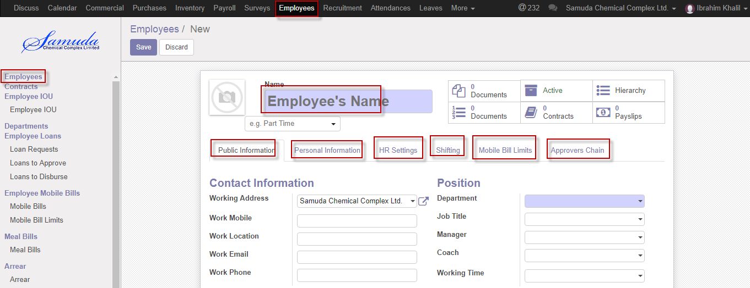

Figure: Create employee

# 21. Contracts

HR manager will create contract information after joining new employee.

## 21.1 Create contracts

New contracts creation require after join new employee.HR manger can do the information setup. Employee wages, Which Department under all info are given here.

We can create Contracts using the menu **Employee ‣ Contracts** and click **Create.**

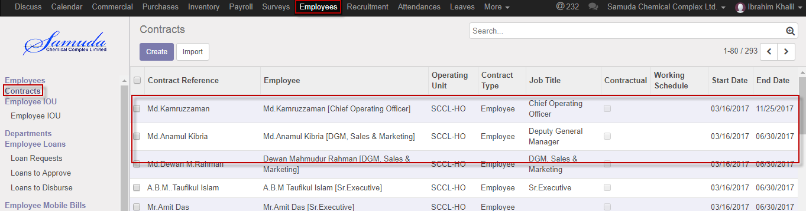

Figure: Contracts List view

We need to set the following:-

**Employee**: Select employee.

**Contract type**: Select contract type.

**Wage:** Enter wage.

**Salary structure:** Select salary structure.

**Duration:** Select duration.

After entering all information click **Save**.

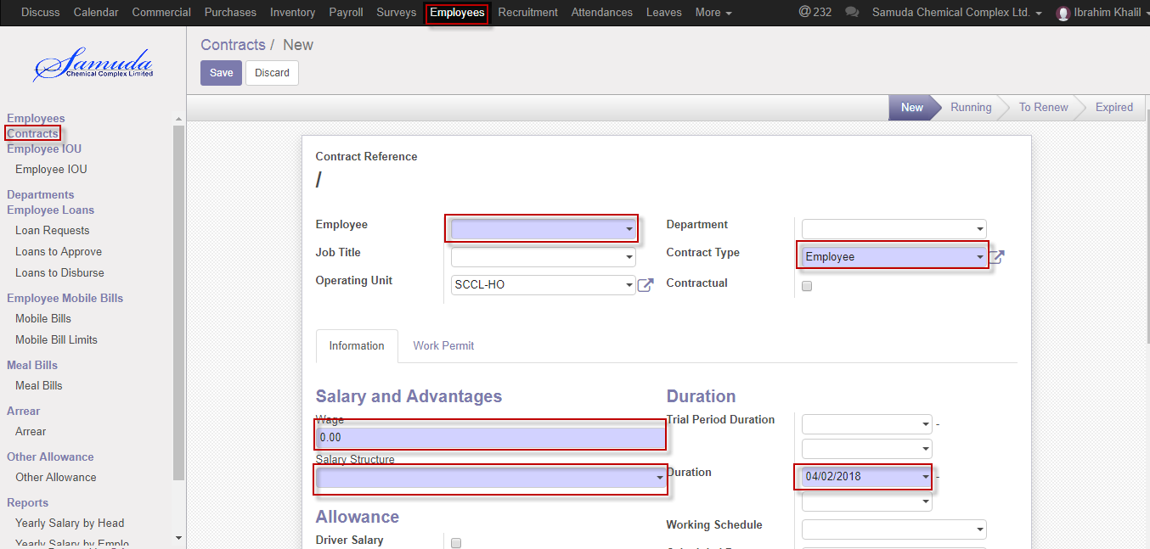

Figure: Create contracts

# 22. Employee IOU

HR manager can set IOU. IOU is short time loan taking from HR end. Which has no installment just has a short info.

## 22.1 Create employee IOU

We can create employee IOU using the menu **Employee ‣ employee IOU** and click **Create.**

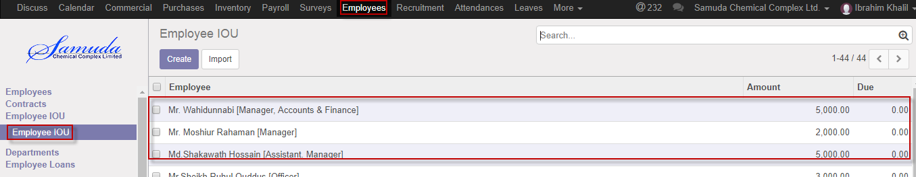

Figure: Employee IOU List view

We need to set the following:-

**Employee**: Select employee.

**Amount**: Enter amount.

After entering all information click **Save**.

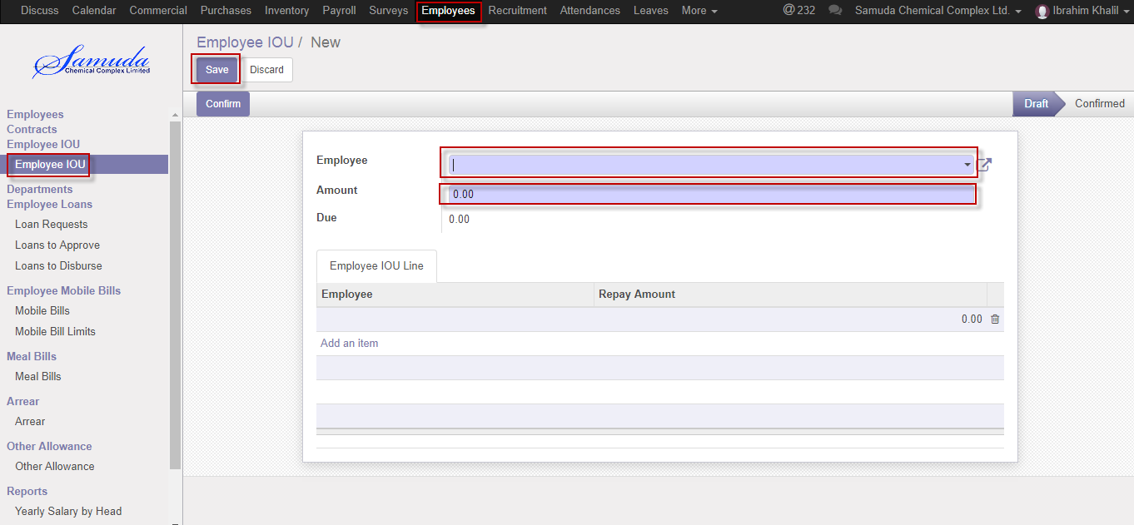

Figure: Create employee IOU

# 23. Departments

HR manager will create departments and departments need for employee department setting which employee under which departments.

## 23.1 Create departments

We can create departments using the menu **Employees ‣ Departments** and click **Create.**

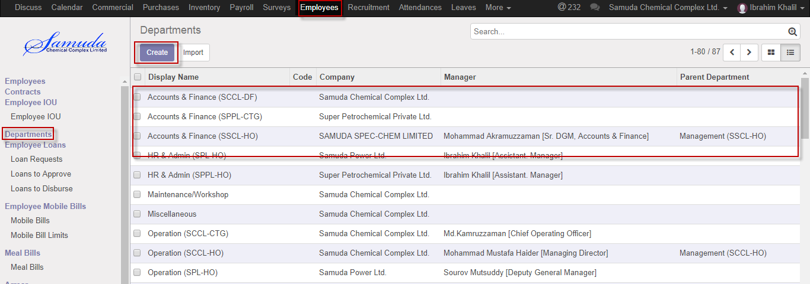

Figure: Departments List view

We need to set the following:-

**Department name**: Enter department name.

**Sequence**: Enter sequence.

**Parent Department**: Select parent departments.

**Company:** select Company.

**Active:** Check active.

After entering all information click **Save**.

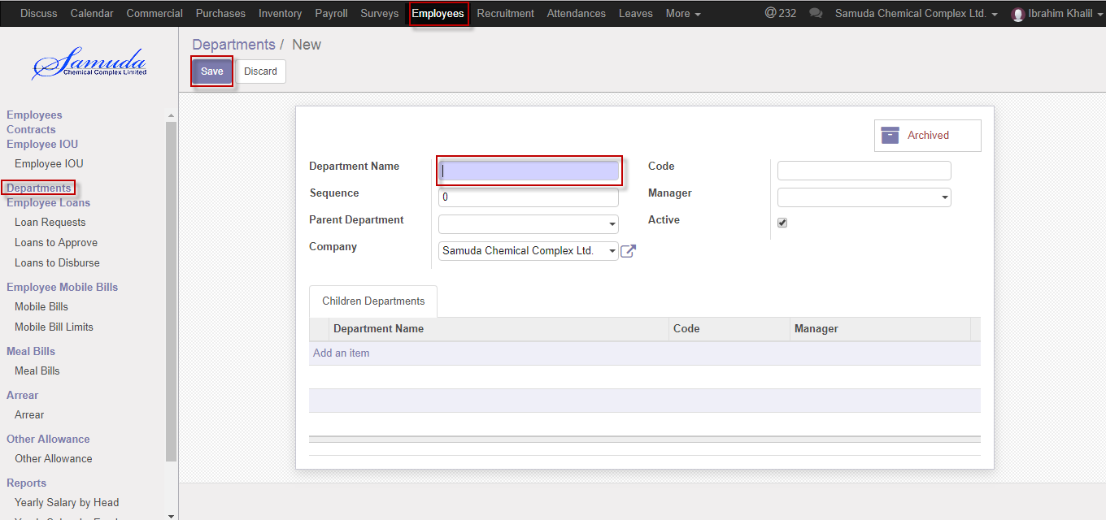

Figure: Create departments

# 24. Loan Request

HR manager will create loan request on behalf of Employee.

## 24.1 Create Loan Request

Some time employee is needed money then employee create loan request or HR manager will create on behalf of Employee and HR manager will approve and disburse.

To create new Loan Request, Using the menu **Employee ‣ Employee loans ‣ Loan request** click **Create**.

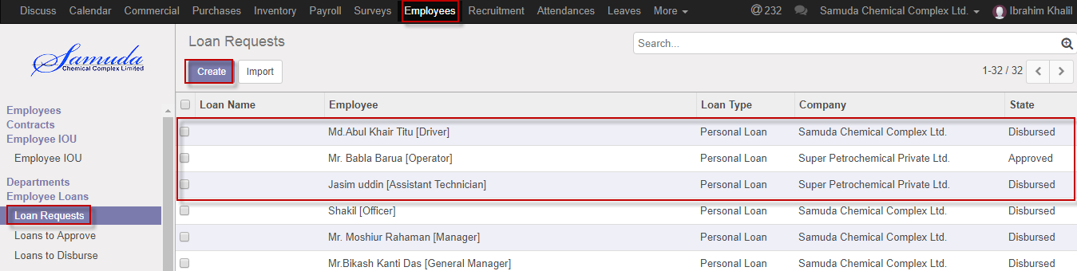

Figure: Loan request List View

You can set the following information:-

**Employee:** Select employee

**Loan Type:** Select a loan type.

**Principal amount:** Enter principal amount.

**Installment amount:** Enter installment amount

**Repayment date:** Select repayment date.

After entering the Loan Request information click **save**.

We can create Loan request Using the menu **Employee ‣Employee loans ‣ Loan Request** click **Create** button.

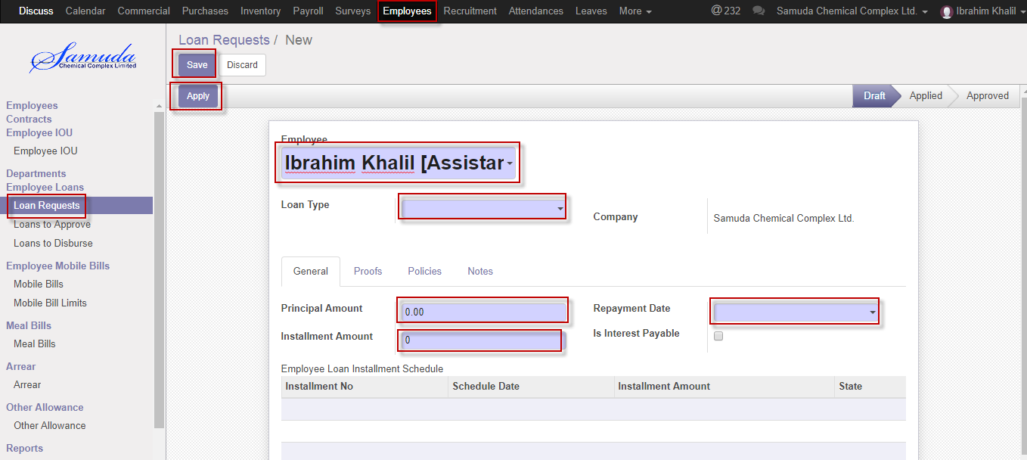

Figure: Create Loan request

# 25. Loan request approval by HR Manager

HR Manager will approve loan request.

## 25.1 Loan request Approve by HR manager

After apply the loan request HR will get the notification. HR Can approve the Loan request. To see the Loan request use the menu **Employee ‣ Employee loan>>Loans to approve**

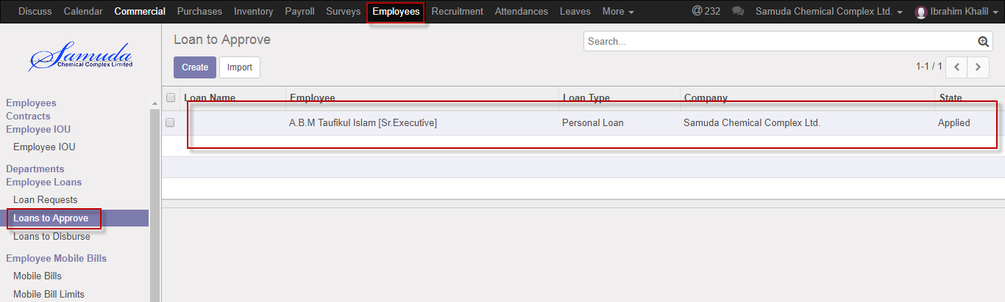

Figure: Loans to approve list view

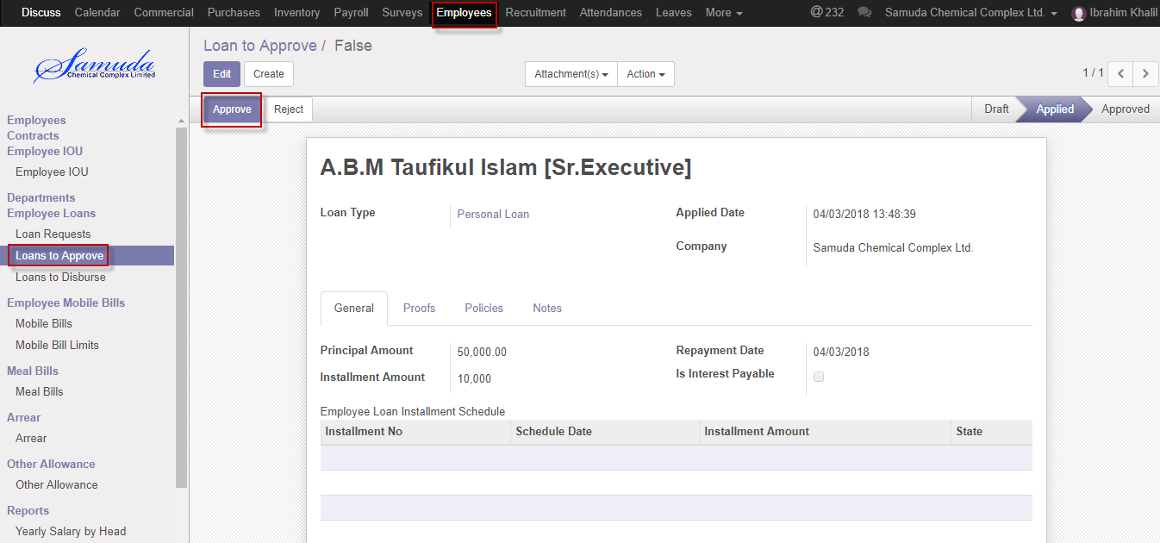

Figure: Loans request Approval

HR manager can approve the loan request by click on **Approve** button.

HR manager can reject the loan request by click **Reject** button.

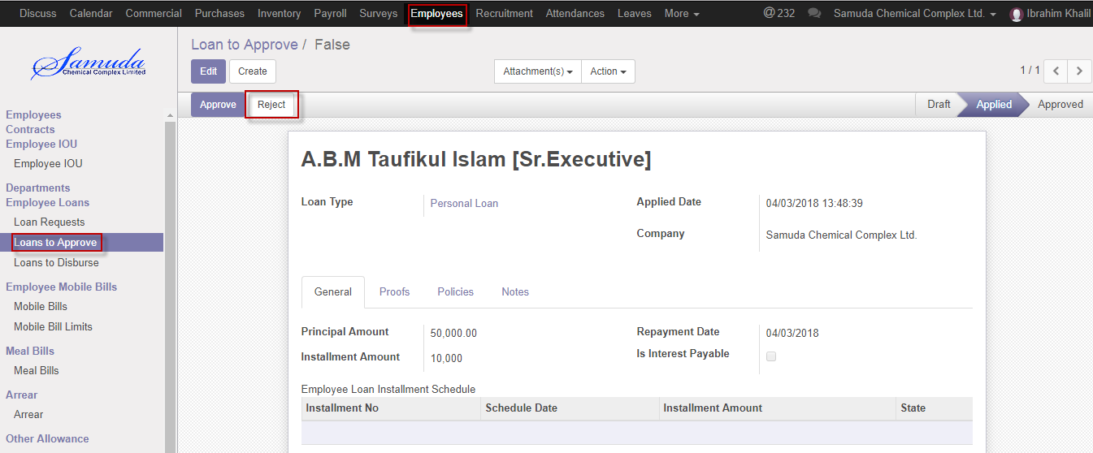

Figure: Loan request reject

# 26. Loans to disburse

HR manager will disburse the Loan request.

## 26.1 Create a Loan disburse

After Loan request approval HR manager will do the loan disburse process.

We can create Loan disburse using the menu **Employees ‣ Employee loans‣ Loans to disburse** and click **Create.**

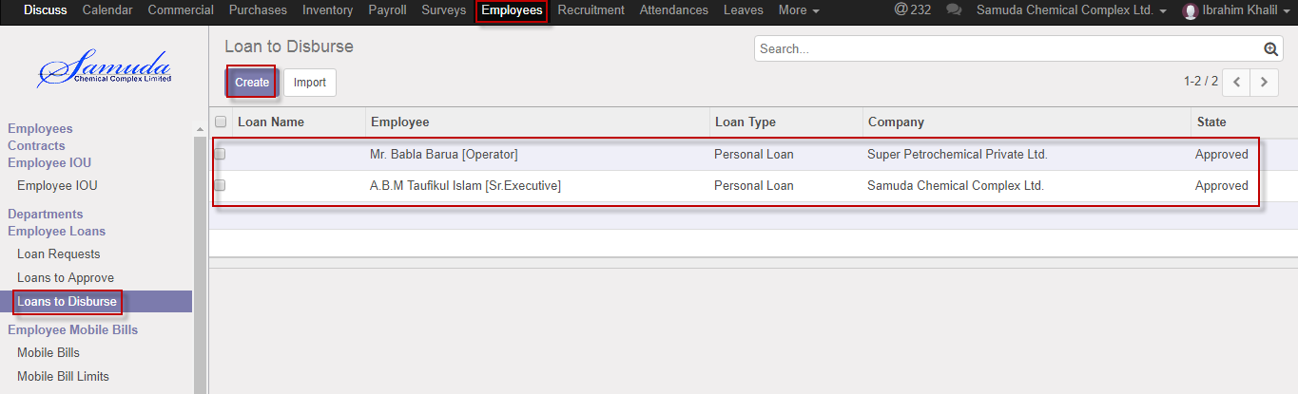

Figure: Loan disburse List view

We need to set the following:-

**Employee**: Select employee.

**Loan type**: select loan type.

**Principal amount:** Enter principal amount.

**Installment amount:** Enter installment amount.

**Repayment date:** Select repayment date.

After entering all information click **Save**.

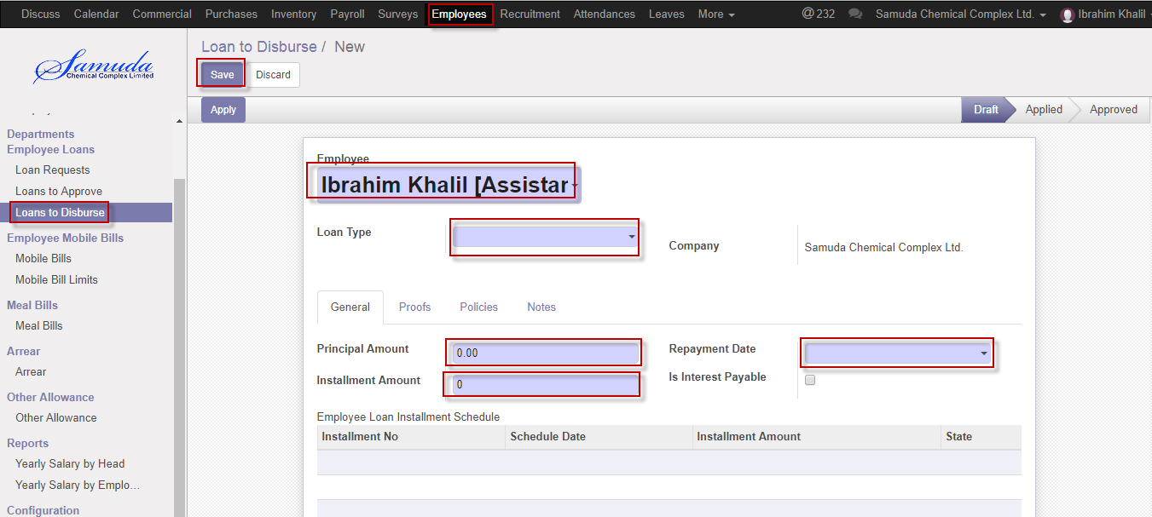

Figure: Create a Loan disburse

HR manager will disburse the Loan disburse by click **disburse** Button.

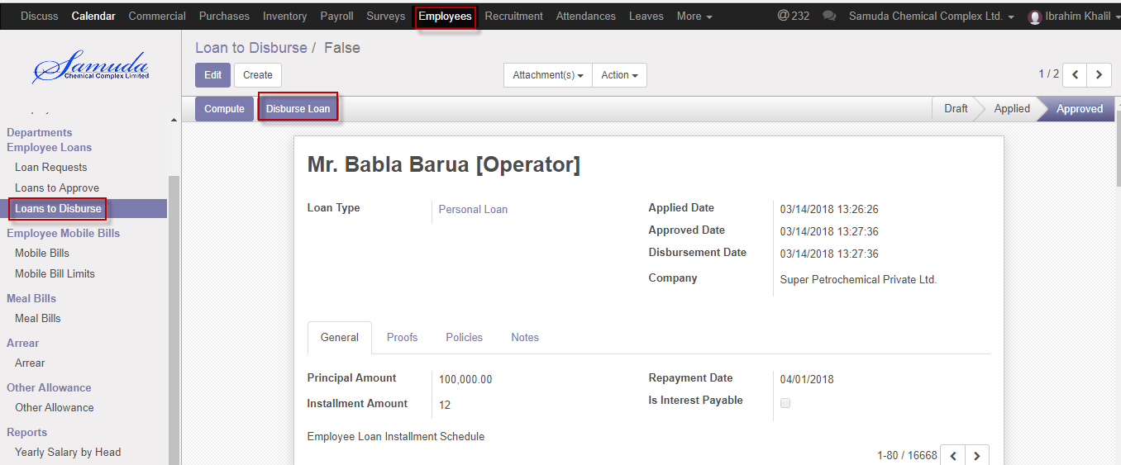

Figure: Loan disburse

# 27. Mobile bills

HR manager is capable to his/her own mobile bills and on behalf of employee against. He/she will approve mobile bills request under his all employee against.

## 27.1 Create a mobile bills

HR manager will setup mobile bills. After entering mobile number will auto tag with Employee if exist mobile number in Employee profile.

We can create mobile bills using the menu **Employees ‣ Mobile bills** and click **Create.**

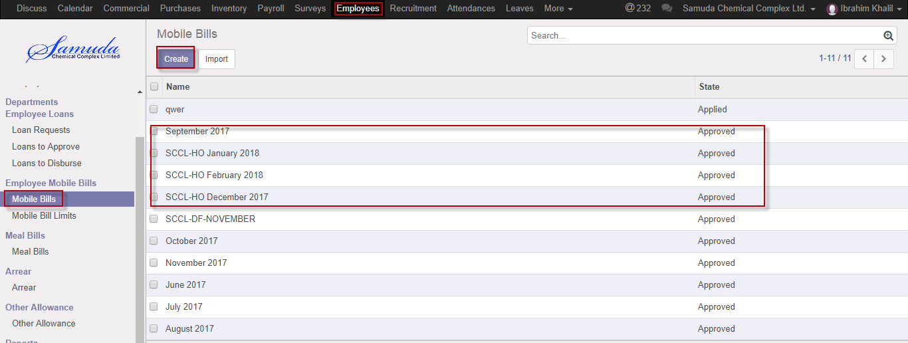

Figure: Mobile bills List view

We need to set the following:-

**Name**: Enter a name.

**Company**: Select a company.

**Mobile number:** Enter mobile number.

**Bill amount:** Enter bill amount.

**Exceed amount:** Enter exceed amount.

After entering all information click **Save**.

HR manager can applied by click **apply** Button

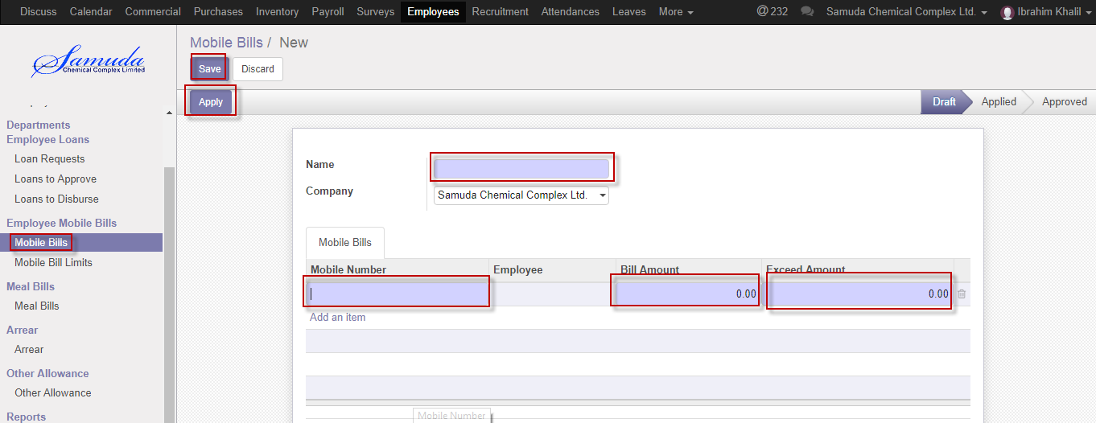

Figure: Create a Mobile bills

HR manager can applied by click **apply** Button

# 28. Mobile bills Approval by HR manager

HR manager will approve mobile bills, which bills is applied state.

## 28.1Mobile bills Approval by HR manager

After applied the mobile bills HR manager will get the notification. HR manager will approve the mobile bills request.

To see the Mobile bills pending request use the menu **Employees ‣ Mobile bills>Pending request**

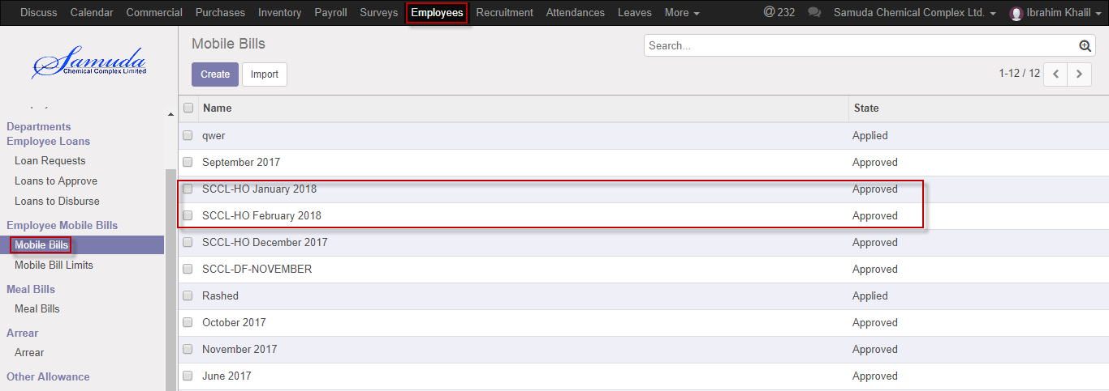

Figure: Pending mobile bills list view

HR manager can approve employee’s Mobile bills request **Employees ‣ Mobile bills>Pending request** 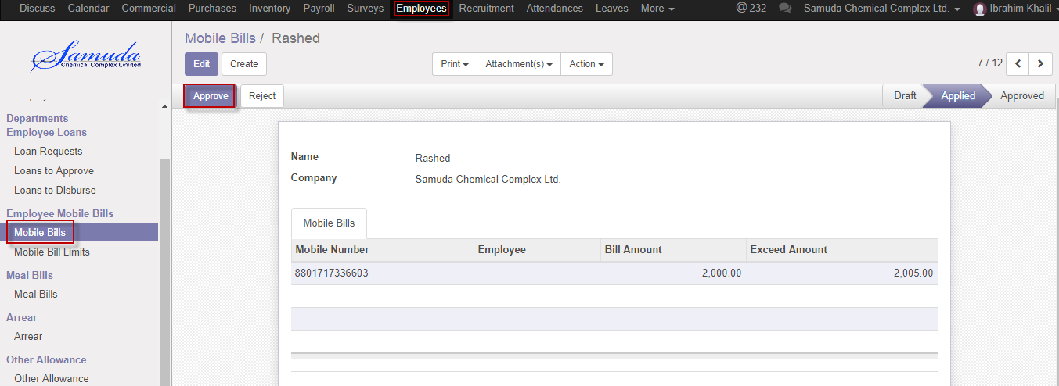

Figure: Mobile bills request Approval

Here HR manager can approve the Mobile bills request by click on **Approve** button. He can update Mobil bills before approval if require.

HR manager can reject mobile bills request by click **Reject** Button.

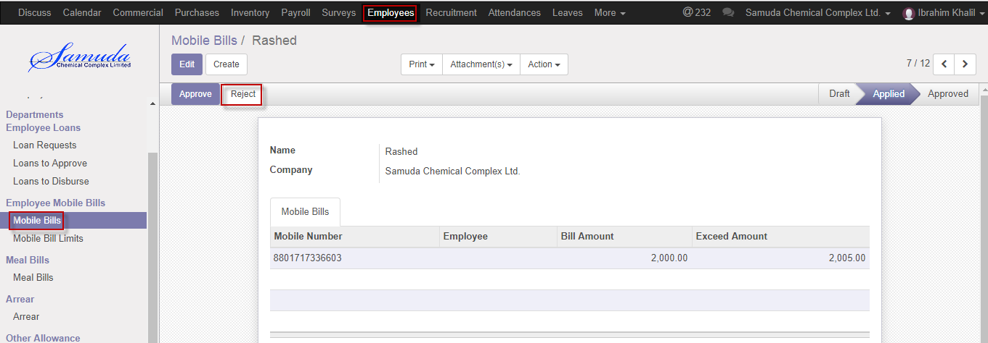

Figure: Mobile bills request reject

# 29. Mobile bill limits

HR manager is capable to his/her own mobile bill limits and on behalf of employee against. He/she will approve mobile bill limits request under his all employee against.

## 29.1 Create a mobile bill limits

HR manager will setup mobile bill limits.

We can create mobile bill limits using the menu **Employees ‣ Mobile bill limits** and click **Create.**

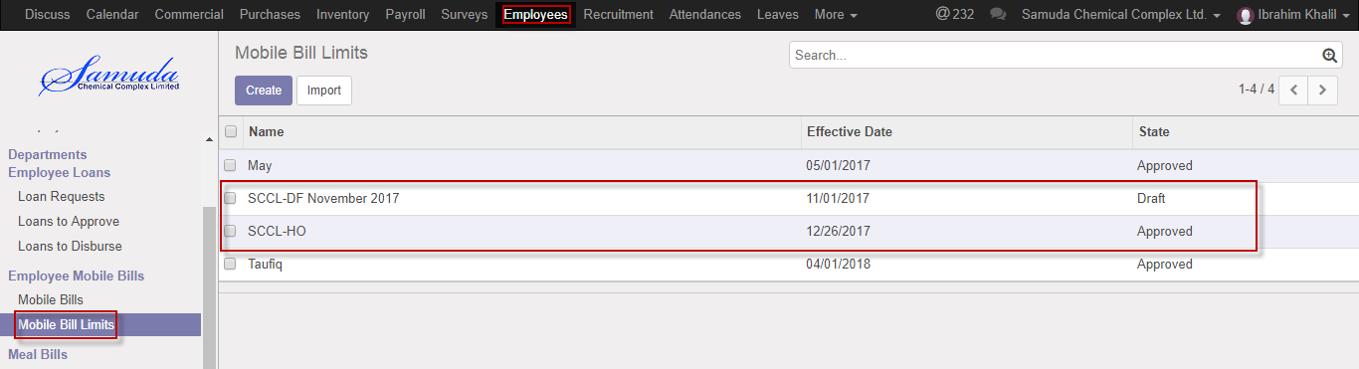

Figure: Mobile bill limits List view

We need to set the following:-

**Name**: Enter a name.

**Effective date**: Select an effective date.

**Company:** select Company.

**Employee:** Select employee.

**Mobile bill limits:** Enter mobile bill limits

After entering all information click **Save**.

HR manager can applied by click **apply** Button

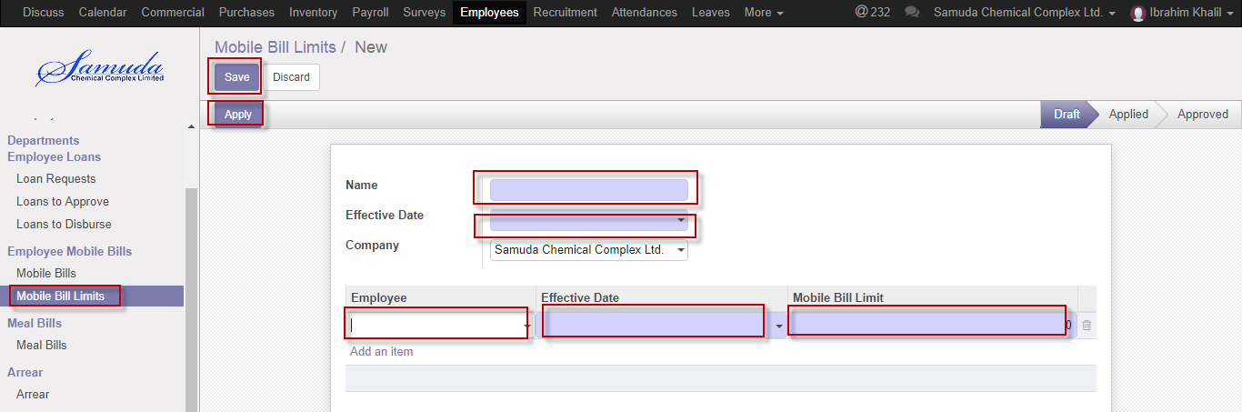

Figure: Create a Mobile bill limits

HR manager can applied by click **apply** Button

# 30. Mobile bill limits Approval by HR manager

HR manager will approve mobile bills, which bills is applied state.

## 30.1Mobile bill limits Approval by HR manager

After applied the mobile bill limits HR manager will get the notification. HR manager will approve the mobile bill limits request.

To see the Mobile bills pending request use the menu **Employees ‣ Employee Mobile bill limits>Pending request**

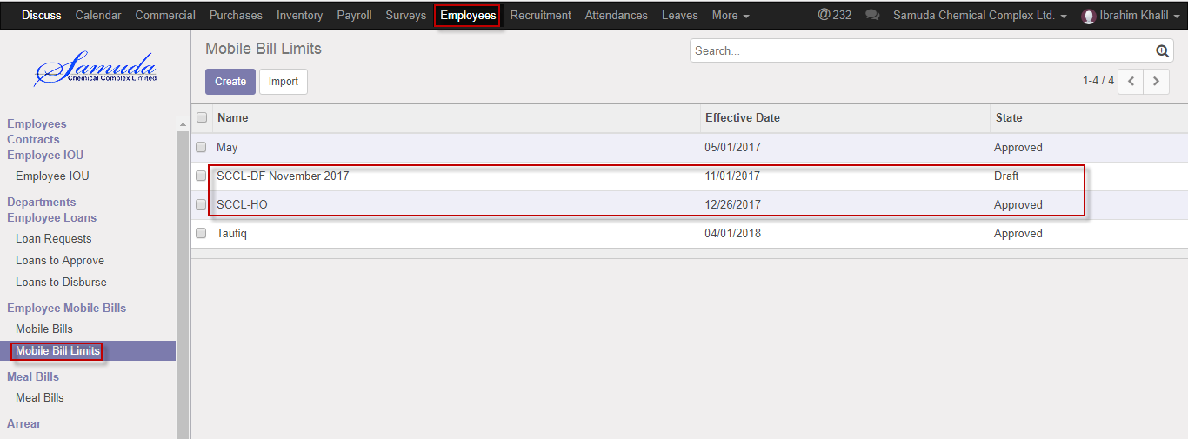

Figure: Pending mobile bill limits list view

HR manager can approve employee’s Mobile bill limits request **Employees ‣ Mobile bill limits>Pending request** 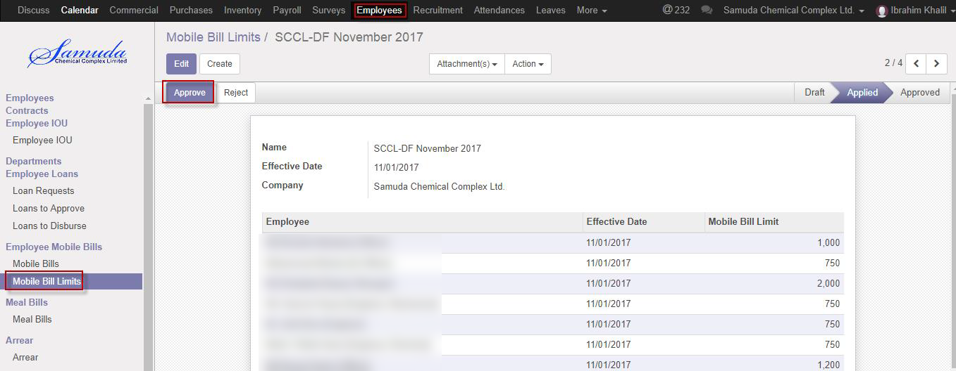

Figure: Mobile bills request Approval

Here HR manager can approve the Mobile bill limits request by click on **Approve** button. He can update Mobile bill limits before approval if require.

HR manager can reject mobile bill limits request by click **Reject** Button.

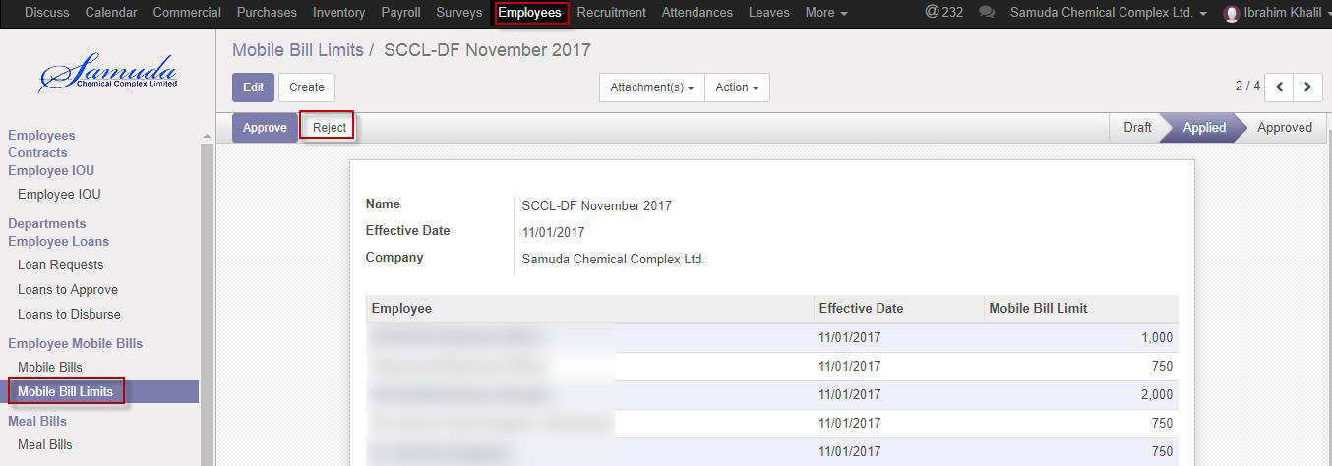

Figure: Mobile bill limits request reject

# 31. Meal bills

HR manager is capable to his/her own meal bills and on behalf of employee against. He/she will approve meal bills request under his all employee against.

## 31.1 Create a meal bills

HR manager will setup meal bills.

We can create meal bills using the menu **Employees ‣ Meal bills** and click **Create.**

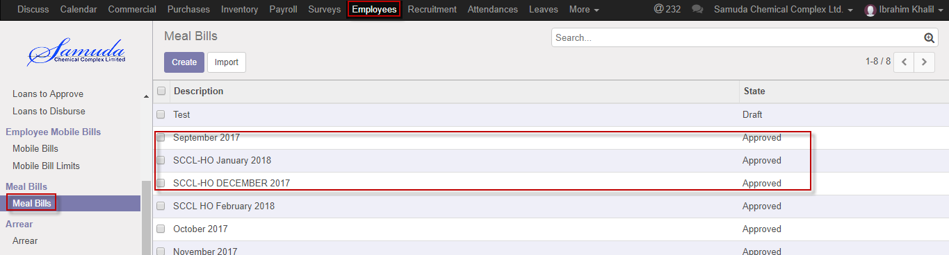

Figure: Meal bills List view

We need to set the following:-

**Description**: Enter a description.

**Company:** select Company.

**Employee:** Select employee.

**Amount:** Enter amount.

After entering all information click **Save**.

HR manager can applied by click **apply** Button

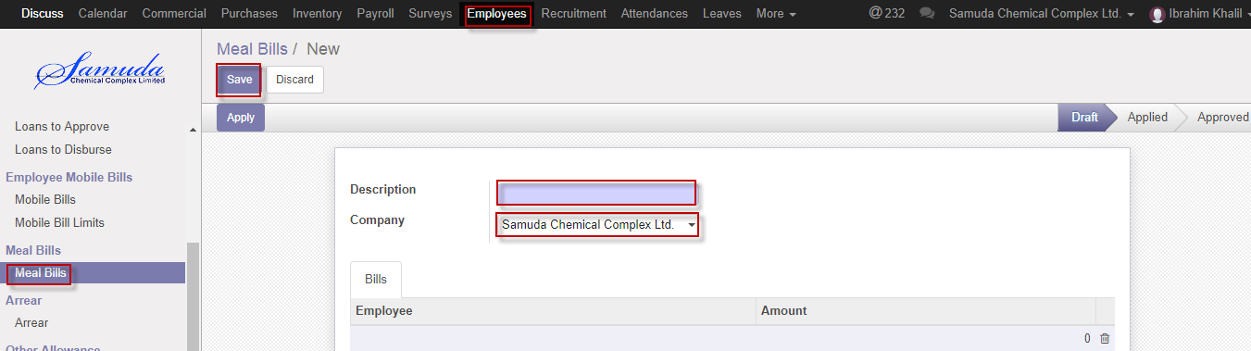

Figure: Create a Meal bill

# 32. Meal bill Approval by HR manager

HR manager will approve meal bills, which bills is applied state.

## 32.1Meal bill Approval by HR manager

After applied the meal bills HR manager will get the notification. HR manager will approve the meal bills request.

To see the Meal bills pending request use the menu **Employees ‣Meal bills>Pending request**

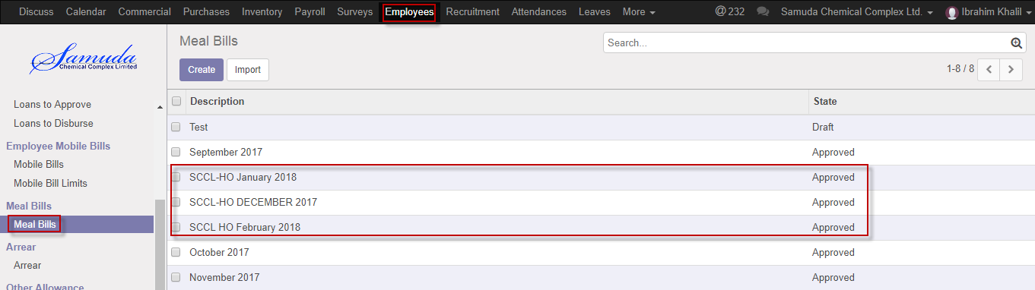

Figure: Pending meal bills list view

HR manager can approve employee’s Meal bills request **Employees ‣ Meal bills>Pending request** 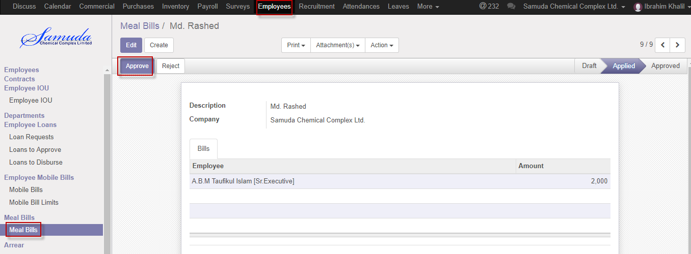

Figure: Meal bills request Approval

Here HR manager can approve the Meal bills request by click on **Approve** button. He can update Meal bills before approval if require.

HR manager can reject meal bills request by click **reject** Button.

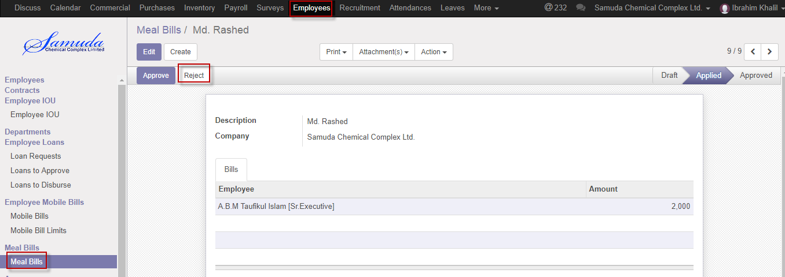

Figure: Meal bills request reject

# 33. Arrear

HR manager is capable to his/her own arrear and on behalf of employee against. He/she will approve arrear request under his all employee against. Generally arrear is overdue of payment.

## 33.1 Create a arrear

HR manager will setup arrear.

We can create arrear using the menu **Employees ‣ Arrear** and click **Create.**

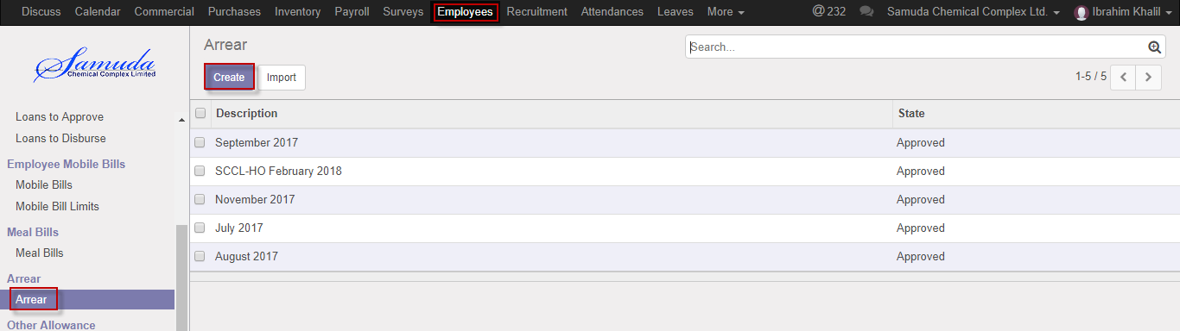

Figure: Arrear List view

We need to set the following:-

**Description**: Enter a description.

**Company:** select Company.

**Employee:** Select employee.

**Amount:** Enter amount.

After entering all information click **Save**.

HR manager can applied by click **apply** Button

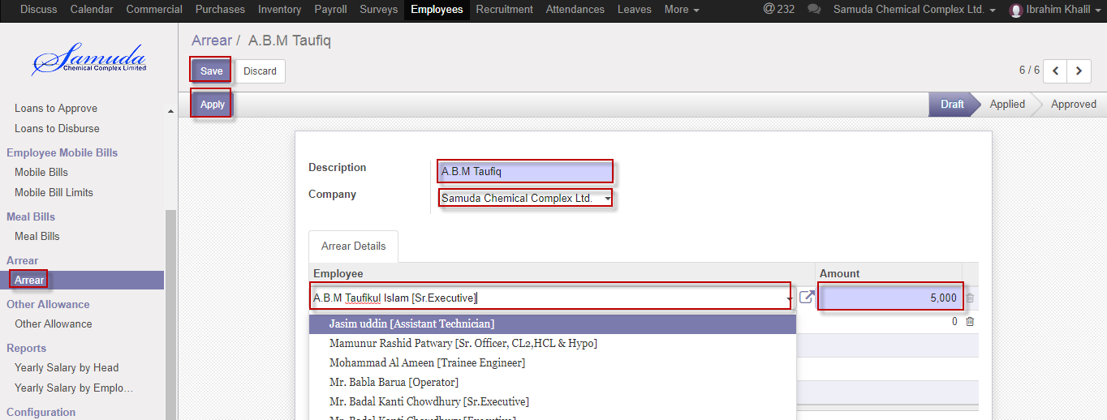

Figure: Create a Arrear

# 34. Arrear Approval by HR manager

HR manager will approve arrear, which bills is applied state.

## 34.1 Arrear Approval by HR manager

After applied the Arrear HR manager will get the notification. HR manager will approve the arrear request.

To see the Arrear pending request use the menu **Employees ‣Arrear>Pending request**

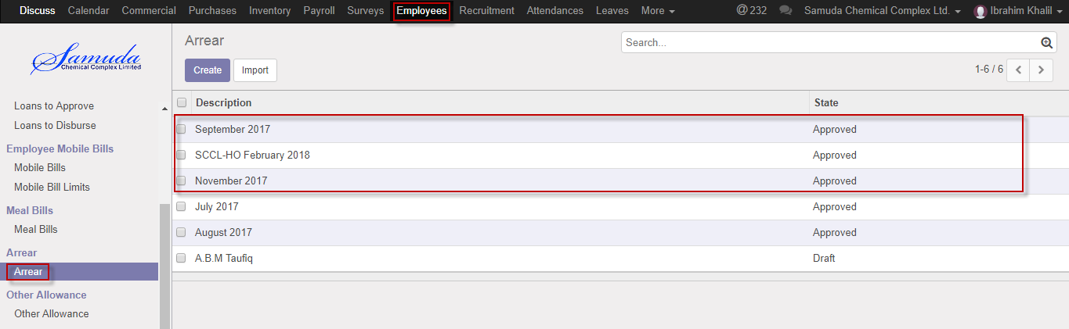

Figure: Pending arrear list view

HR manager can approve arrear request **Employees ‣ Arrear>Pending request** 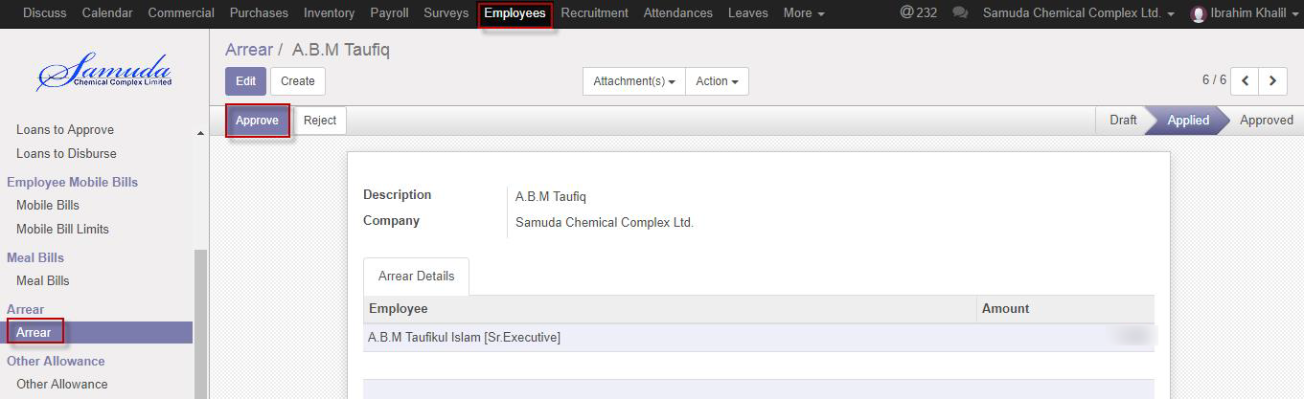

Figure: Arrear request Approval

Here HR manager can approve the arrear request by click on **Approve** button. He can update arrear before approval if require.

HR manager can reject arrear request by click **reject** Button.

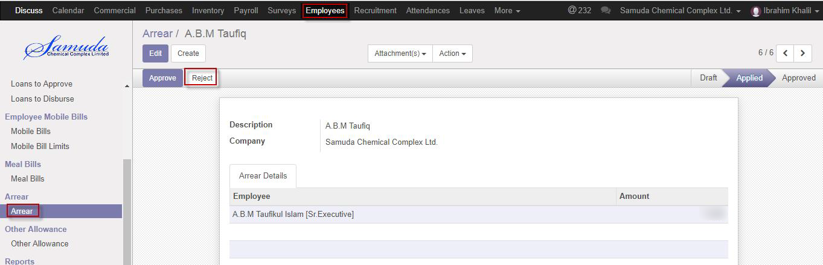

Figure: Arrear request reject

# 35. Other Allowance

HR manager is capable to his/her own other allowance and on behalf of employee against. He/she will approve other allowance request under his all employee against.

## 35.1 Create an Other allowance

HR manager will setup other allowance.

We can create other allowance using the menu **Employees ‣ other allowance** and click **Create.**

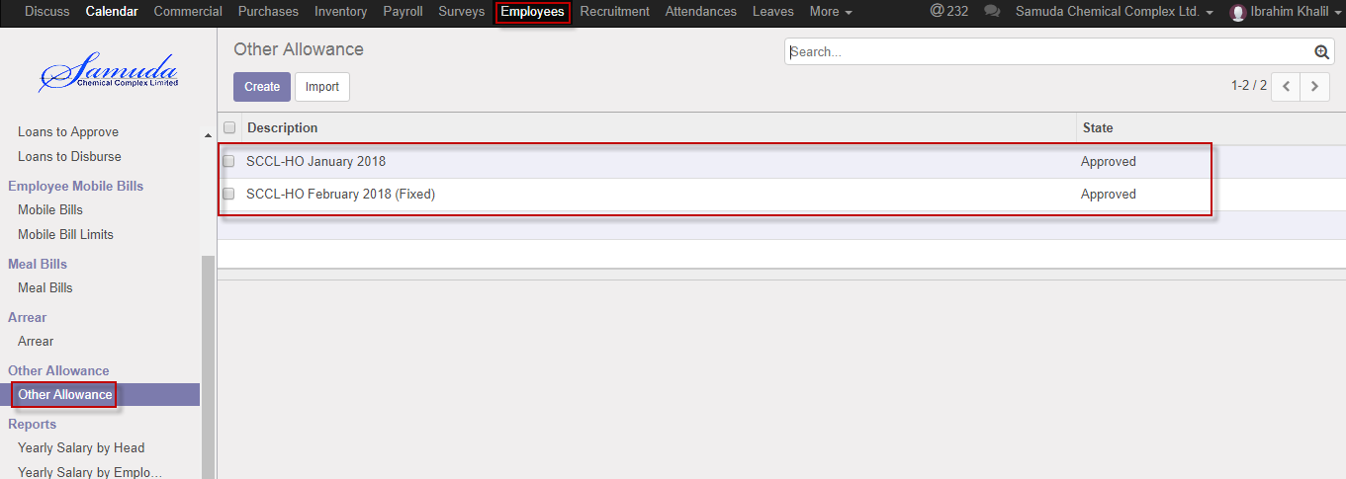

Figure: Other allowance List view

We need to set the following:-

**Description**: Enter a description.

**Company:** select Company.

**Employee:** Select employee.

**Amount:** Enter amount.

After entering all information click **Save**.

HR manager can applied by click **apply** Button

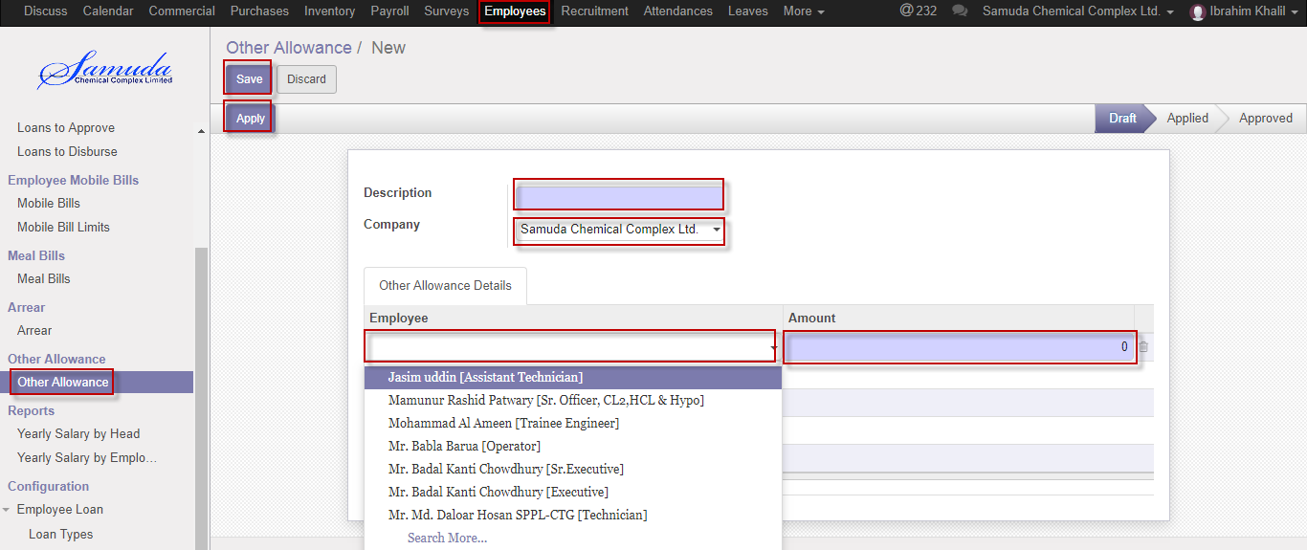

Figure: Create an Other allowance

# 36. Other allowance approval by HR manager

HR manager will approve other allowance, which bills is applied state.

## 36.1 Other allowance approval by HR manager

After applied the other allowance HR manager will get the notification. HR manager will approve the other allowance request.

To see the other allowance pending request use the menu **Employees ‣Other allowance>Pending request**

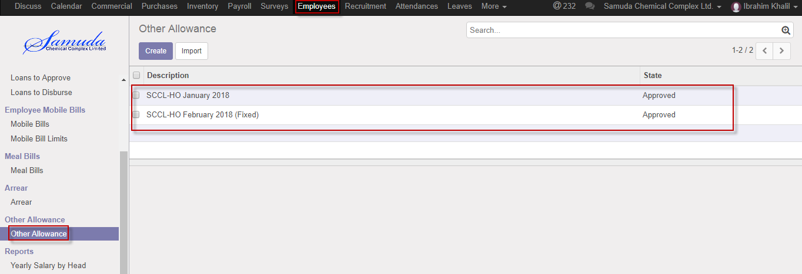

Figure: Pending other allowance list view

HR manager can approve other allowance request **Employees ‣ other allowance>Pending request** 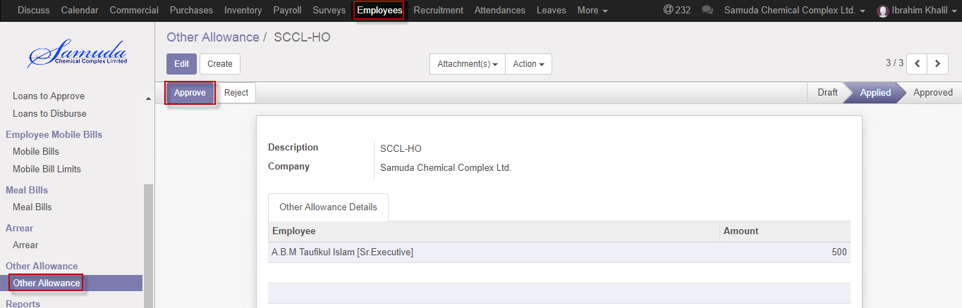

Figure: Other allowance request Approval

Here HR manager can approve the other allowance request by click on **Approve** button. He can update other allowance before approval if require.

HR manager can reject other allowance request by click **reject** Button.

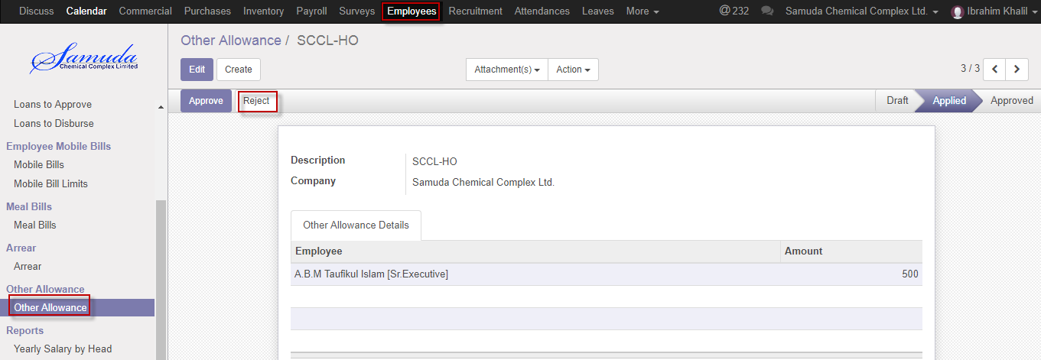

Figure: Other allowance request reject

# 37. Reports

In employee module reports contain, Employee salary, leave, account head wise reports etc. Reports document containing information graphic, or tabular form, prepared on ad hoc, periodic, recurring, regular, or as required basis.

## 37.1 Yearly salary by head reports view by HR manager

HR manager will view yearly account head wise salary if he/she wants like .Basic allowance, gross, etc. individually will show.

To see the Yearly salary by head use the menu **Employees ‣Reports>** **Yearly salary by head**

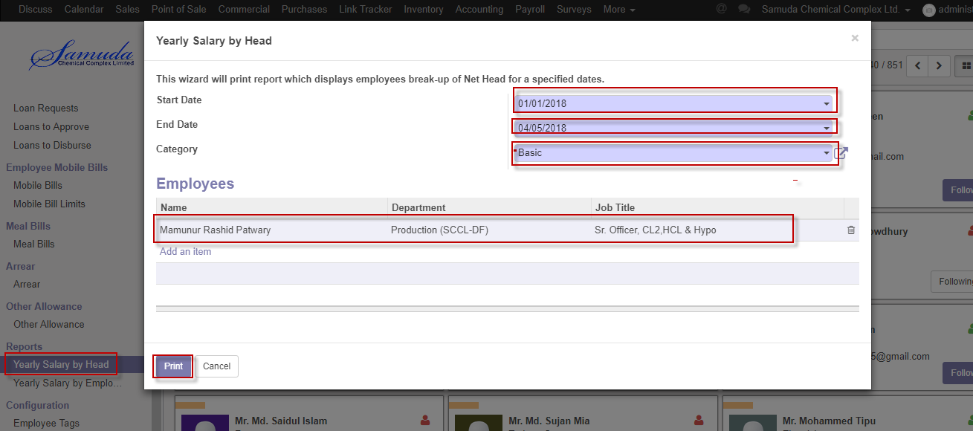

Figure: Yearly salary by head print view

We need to set the following:-

**Start date**: Select start date.

**End date:** select end date.

**Category:** Select category.

**Employee:** Select employee.

After entering all information click **Print**.

## 37.2 Yearly salary by employee reports view by HR manager

HR manager will view yearly employee wise salary if he/she wants like .One specific employee against, January to December.

To see the Yearly salary by employee use the menu **Employees ‣Reports>** **Yearly salary by employee**

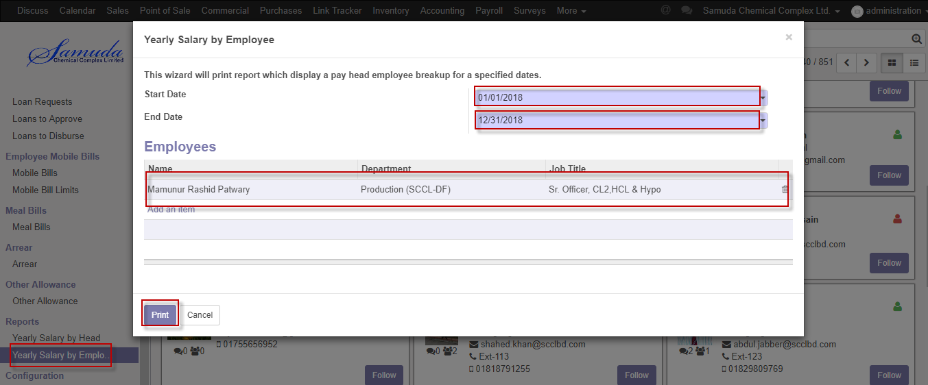

Figure: Yearly salary by employee print view

We need to set the following:-

**Start date**: Select start date.

**End date:** select end date.

**Employee:** Select employee.

After entering all information click **Print**.

## 37.3 Attendance reports view by HR manager

HR manager will view attendance reports if he/she wants. Various type wise reports are viewed by HR manager.

To see the use the menu **Attendance ‣Reports>** **Attendance reports**

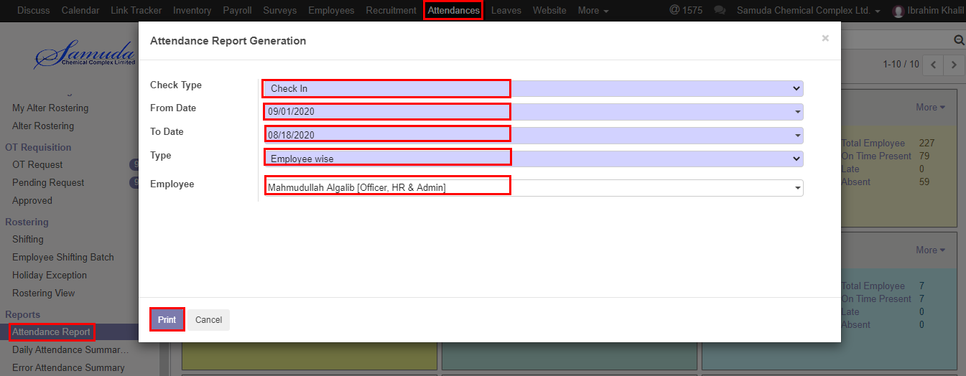

Figure: Attendance reports print view

We need to set the following:-

**Check type**: Select check type.

**From date:** select from date.

**To date:** Select to date.

**Type:** Select type.

After entering all information click **Print**.

## 37.4 Daily attendance summary reports view by HR manager

HR manager will view Daily attendance summary reports if he/she wants. To see the use the menu **Attendance ‣Reports>** **Daily attendance summary reports**

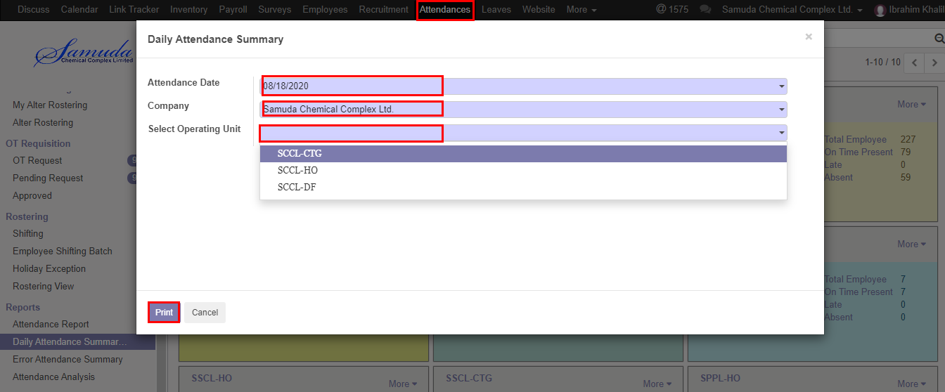

Figure: Daily Attendance summary reports print view

We need to set the following:-

**Attendance Date**: Select attendance date.

**Company:** select company.

**Operating unit:** Select operating unit.

After entering all information click **Print**.

## 37.5 Error attendance summary reports view by HR manager

HR manager will view Error attendance summary reports if he/she wants. User also able to view Type wise reports. To see the use the menu **Attendance ‣Reports>** **Error attendance summary reports**

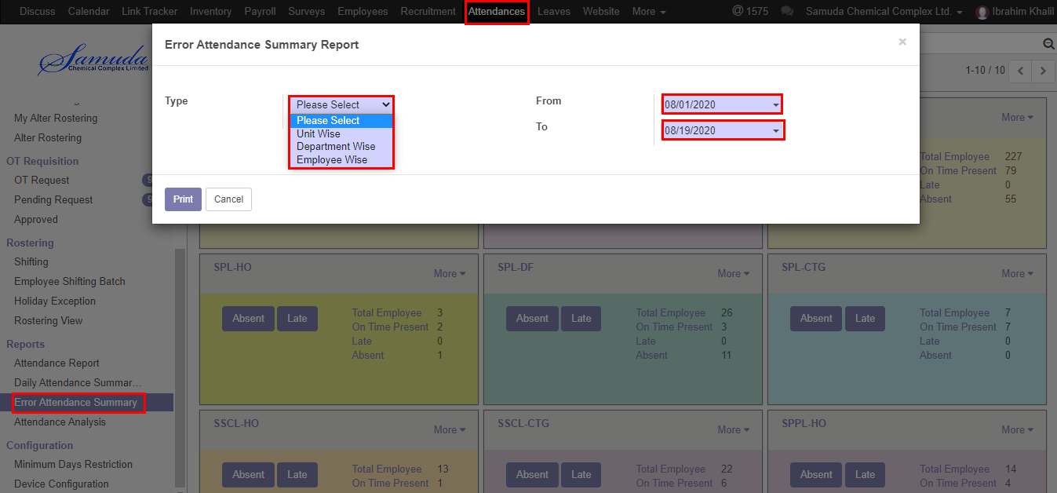

Figure: Error Attendance summary reports print view

We need to set the following:-

**Select type**: Select type.

**From:** select date from.

**To:** Select To date.

After entering all information click **Print**.

## 37.6 Attendance analysis reports view by HR manager

HR manager will view Attendance analysis reports if he/she wants. User is able to view report with expand using various terms. Also able to download the excel format. To see the use the menu **Attendance ‣Reports>** **Attendance analysis reports**

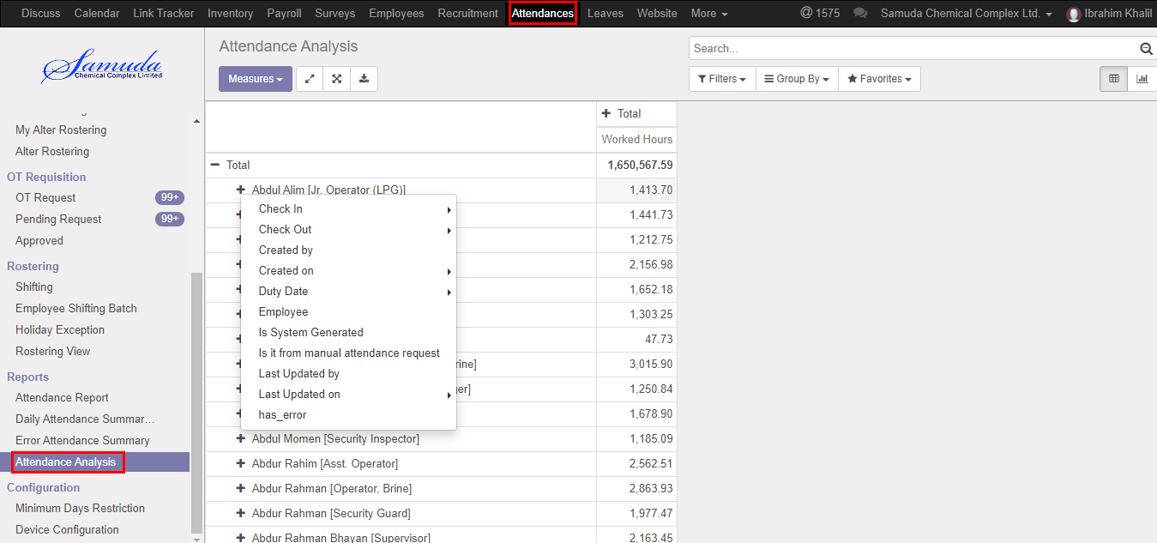

Figure: Attendance analysis reports print view

## 37.7 Leaves analysis reports view by HR manager

HR manager will view Leaves analysis reports if he/she wants. User is able to view report with expand using various terms. Also able to download the excel format. To see the use the menu **Leave ‣Reports>** **Leaves analysis reports**

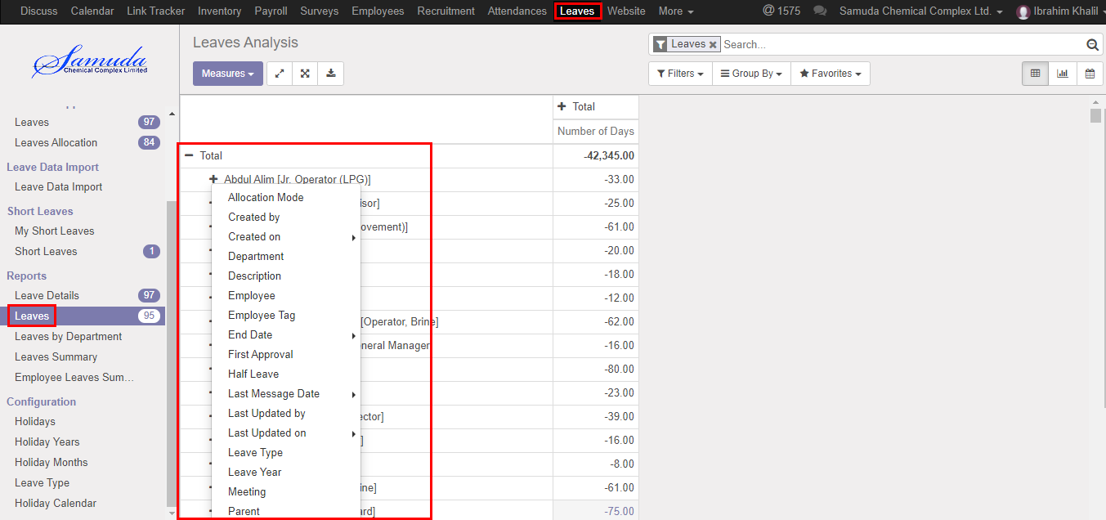

Figure: Leaves analysis reports print view

## 37.8 Leaves summary reports view by HR manager

HR manager will view Leaves summary reports if he/she wants. To see the use the menu **Leave ‣Reports>** **Leave summary reports**

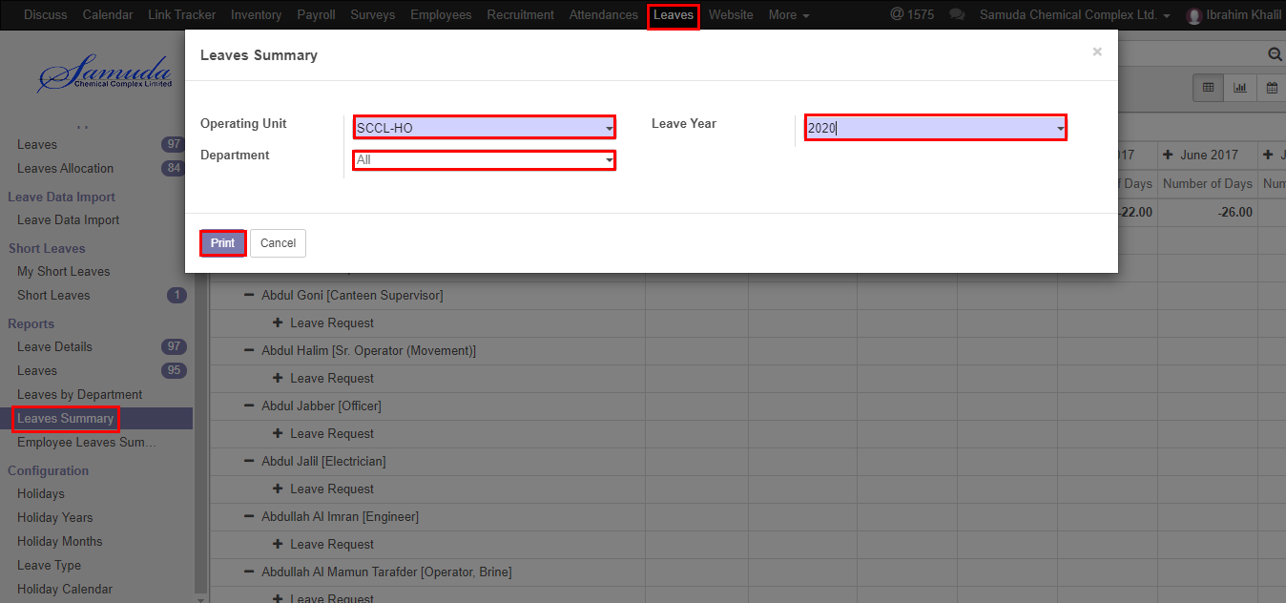

Figure: Leave summary reports print view

We need to set the following:-

**Operating unit**: Select operating unit.

**Leave Year:** Select leave year.

**Department:** Select department.

After entering all information click **Print**.

## 37.9 Employee Leaves summary reports view by HR manager

HR manager will view Employee Leaves summary reports if he/she wants. To see the use the menu **Leave ‣Reports>** **Employee leave summary reports**

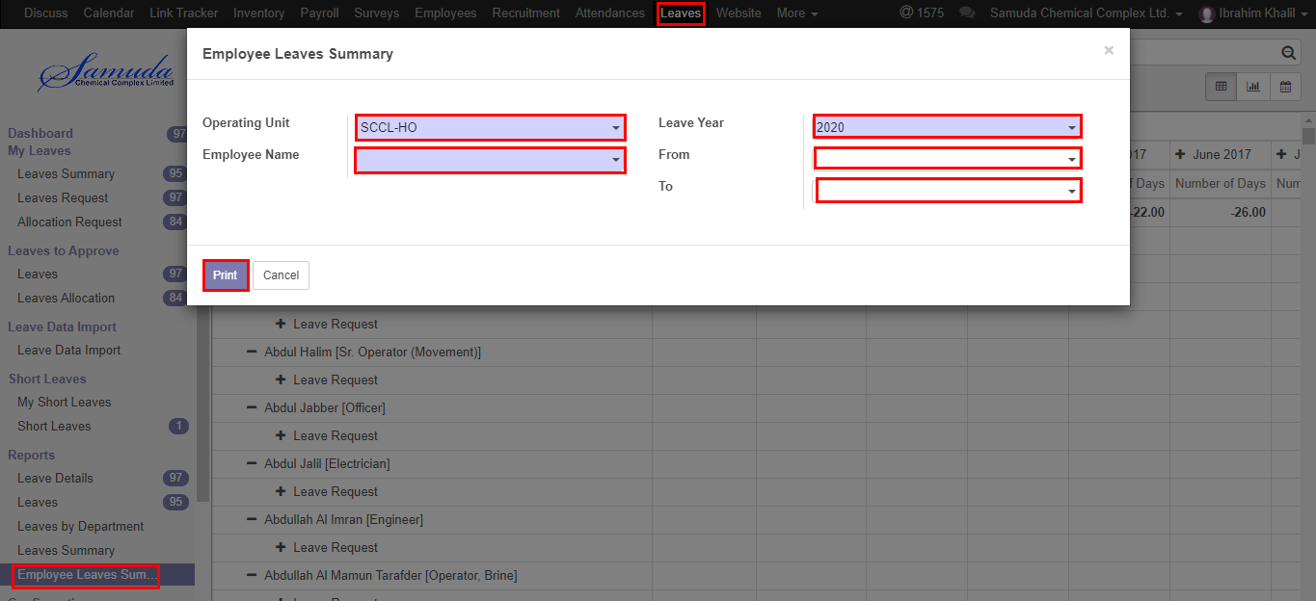

Figure: Employee Leave summary reports print view

We need to set the following:-

**Operating unit**: Select operating unit.

**Leave Year:** Select leave year.

**Employee name:** Select employee name.

**Leave year:** Select leave year.

**From:** Select from date.

**To:** Select to date.

After entering all information click **Print**.